Whole Number Operations, Comparison and Ordering

Operations

Addition
# Source: AI Source: Provided by: [Data Path: Persons Table -> ID Column: 1, Name_En Column: Motasem Essam] -> From: [ChatGPT] on [7/11/2026]
Addition is one of the four basic arithmetic operations. It is the process of combining two or more whole numbers to find their total or sum.
Whole number addition is one of the first mathematical operations learned and is widely used in everyday life for counting, measuring, and solving problems.

Definition
# Source: AI Source: Provided by: [Data Path: Persons Table -> ID Column: 1, Name_En Column: Motasem Essam] -> From: [ChatGPT] on [7/11/2026]
Addition is the arithmetic operation of finding the total amount by combining two or more whole numbers.
The result of addition is called the sum.
Mathematically:
$$a+b=c$$
where:
- $a$is the first addend
- $b$is the second addend
- $c$is the sum

Addition Symbol
# Source: AI Source: Provided by: [Data Path: Persons Table -> ID Column: 1, Name_En Column: Motasem Essam] -> From: [ChatGPT] on [7/11/2026]
The symbol for addition is:
$$+$$
Example:
$$8+5=13$$

Examples
# Source: AI Source: Provided by: [Data Path: Persons Table -> ID Column: 1, Name_En Column: Motasem Essam] -> From: [ChatGPT] on [7/11/2026]
Example 1
Add:
$$7+4$$
Solution:
$$7+4=11$$

Example 2
Add:
$$25+18$$
Solution:
$$25+18=43$$

Example 3
Add:
$$150+275$$
Solution:
$$150+275=425$$

Example 4
Add three whole numbers:
$$12+8+15$$
Solution:
$$12+8=20 \\ 20+15=35$$
Therefore,
$$12+8+15=35$$

Vertical Addition
# Source: AI Source: Provided by: [Data Path: Persons Table -> ID Column: 1, Name_En Column: Motasem Essam] -> From: [ChatGPT] on [7/11/2026]
Example:
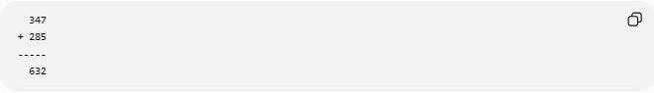
347
+ 285
-----
632
Steps:
- Add the ones column.
- Add the tens column.
- Add the hundreds column.
- Regroup (carry) when a column sum is 10 or greater.

Addition with Carrying (Regrouping)
# Source: AI Source: Provided by: [Data Path: Persons Table -> ID Column: 1, Name_En Column: Motasem Essam] -> From: [ChatGPT] on [7/11/2026]
Example:
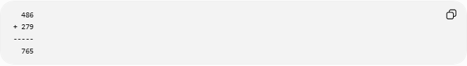
486
+ 279
-----
765
Step-by-step:
- Ones:
$$6+9=15$$
Write 5, carry 1.
- Tens:
$$1+8+7=16$$
Write 6, carry 1.
- Hundreds:
$$1+4+2=7$$
Result:
$$486+279=765$$

Properties of Addition

1. Closure Property
# Source: AI Source: Provided by: [Data Path: Persons Table -> ID Column: 1, Name_En Column: Motasem Essam] -> From: [ChatGPT] on [7/11/2026]
The sum of two whole numbers is always a whole number.
$$a,b∈W⇒a+b∈W$$
Example:
$$18+27=45$$

2. Commutative Property
# Source: AI Source: Provided by: [Data Path: Persons Table -> ID Column: 1, Name_En Column: Motasem Essam] -> From: [ChatGPT] on [7/11/2026]
Changing the order of the addends does not change the sum.
$$a+b=b+a$$
Example:
$$12+7=7+12=19$$

3. Associative Property
# Source: AI Source: Provided by: [Data Path: Persons Table -> ID Column: 1, Name_En Column: Motasem Essam] -> From: [ChatGPT] on [7/11/2026]
Changing the grouping does not change the sum.
$$\left(a+b)+c=a+(b+c\right)$$
Example:
$$(5+3)+4=5+(3+4)=12$$

4. Identity Property
# Source: AI Source: Provided by: [Data Path: Persons Table -> ID Column: 1, Name_En Column: Motasem Essam] -> From: [ChatGPT] on [7/11/2026]
Zero is the additive identity.
$$a+0=a$$
Example:
$$54+0=54$$

Addition Table (0–9)
# Source: AI Source: Provided by: [Data Path: Persons Table -> ID Column: 1, Name_En Column: Motasem Essam] -> From: [ChatGPT] on [7/11/2026]
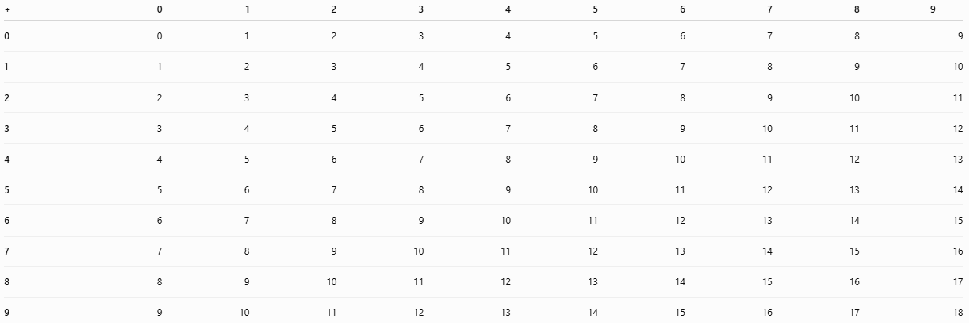
+ | 0 | 1 | 2 | 3 | 4 | 5 | 6 | 7 | 8 | 9
0 | 0 | 1 | 2 | 3 | 4 | 5 | 6 | 7 | 8 | 9
1 | 1 | 2 | 3 | 4 | 5 | 6 | 7 | 8 | 9 | 10
2 | 2 | 3 | 4 | 5 | 6 | 7 | 8 | 9 | 10 | 11
3 | 3 | 4 | 5 | 6 | 7 | 8 | 9 | 10 | 11 | 12
4 | 4 | 5 | 6 | 7 | 8 | 9 | 10 | 11 | 12 | 13
5 | 5 | 6 | 7 | 8 | 9 | 10 | 11 | 12 | 13 | 14
6 | 6 | 7 | 8 | 9 | 10 | 11 | 12 | 13 | 14 | 15
7 | 7 | 8 | 9 | 10 | 11 | 12 | 13 | 14 | 15 | 16
8 | 8 | 9 | 10 | 11 | 12 | 13 | 14 | 15 | 16 | 17
9 | 9 | 10 | 11 | 12 | 13 | 14 | 15 | 16 | 17 | 18

Real-Life Applications
# Source: AI Source: Provided by: [Data Path: Persons Table -> ID Column: 1, Name_En Column: Motasem Essam] -> From: [ChatGPT] on [7/11/2026]
Addition of whole numbers is used in:
- Counting money
- Shopping totals
- Calculating scores
- Counting students
- Inventory management
- Population counts
- Measuring distances
- Tracking expenses

Real-Life Examples
# Source: AI Source: Provided by: [Data Path: Persons Table -> ID Column: 1, Name_En Column: Motasem Essam] -> From: [ChatGPT] on [7/11/2026]
1. Shopping
Sarah buys:
- A notebook for 25
- A pen for 8
- An eraser for 3
Total cost:
$$25+8+3=36$$
She pays 36 in total.

2. Counting Students
There are:
- 18 boys
- 22 girls
Total students:
$$18+22=40$$
The class has 40 students.

3. Saving Money
Ali saves:
- 120 dollars in January
- 150 dollars in February
Total savings:
$$120+150=270$$
Ali has saved 270 dollars.

4. Library Books
A library receives:
- 350 science books
- 275 history books
Total new books:
$$350+275=625$$
The library receives 625 books.

5. Fruit Basket
A basket contains:
- 12 apples
- 9 oranges
- 14 bananas
Total fruits:
$$12+9+14=35$$
The basket contains 35 fruits.

6. Traveling Distance
A family travels:
- 180 km on Saturday
- 220 km on Sunday
Total distance traveled:
$$180+220=400\text{ km}$$
They travel 400 km altogether.

7. Football Scores
A team scores:
- 14 points in the first half
- 17 points in the second half
Total score:
$$14+17=31$$
The team scores 31 points.

8. Inventory
A store has:
- 450 bottles in storage
- Receives 125 more bottles
Total inventory:
$$450+125=575$$
The store now has 575 bottles.

Common Mistakes
# Source: AI Source: Provided by: [Data Path: Persons Table -> ID Column: 1, Name_En Column: Motasem Essam] -> From: [ChatGPT] on [7/11/2026]
- Forgetting to carry when a column sum is 10 or greater.
- Misaligning place values in vertical addition.
- Adding digits from different place-value columns.

Key Points
# Source: AI Source: Provided by: [Data Path: Persons Table -> ID Column: 1, Name_En Column: Motasem Essam] -> From: [ChatGPT] on [7/11/2026]
- Addition combines two or more whole numbers into one total.
- The result of addition is called the sum.
- The symbol for addition is +.
- Whole numbers are closed under addition.
- Addition satisfies the closure, commutative, associative, and identity properties.
- Regrouping (carrying) is used when the sum of digits in a place-value column is 10 or more.

Conclusion
# Source: AI Source: Provided by: [Data Path: Persons Table -> ID Column: 1, Name_En Column: Motasem Essam] -> From: [ChatGPT] on [7/11/2026]
Addition is the arithmetic operation used to combine whole numbers and find their total. It is a fundamental operation in mathematics and everyday life. Whole number addition always produces another whole number and follows important mathematical properties such as closure, commutativity, associativity, and the identity property, making it a reliable and essential operation for problem-solving.

Subtraction
# Source: AI Source: Provided by: [Data Path: Persons Table -> ID Column: 1, Name_En Column: Motasem Essam] -> From: [ChatGPT] on [7/11/2026]
Subtraction is one of the four basic arithmetic operations. It is the process of finding the difference between two whole numbers by taking one number away from another.
Whole number subtraction is commonly used to determine how many remain, how much is left, or the difference between two quantities.

Definition
# Source: AI Source: Provided by: [Data Path: Persons Table -> ID Column: 1, Name_En Column: Motasem Essam] -> From: [ChatGPT] on [7/11/2026]
Subtraction is the arithmetic operation of removing one quantity from another to find the difference.
Mathematically:
$$a-b=c$$
where:
- $a$is the minuend (the number from which another number is subtracted).
- $b$is the subtrahend (the number being subtracted).
- $c$is the difference (the result of subtraction).
For subtraction of whole numbers, the result is a whole number only when:
$$a≥b$$

Subtraction Symbol
# Source: AI Source: Provided by: [Data Path: Persons Table -> ID Column: 1, Name_En Column: Motasem Essam] -> From: [ChatGPT] on [7/11/2026]
The symbol for subtraction is:
$$-$$
Example:
$$15-7=8$$

Examples
# Source: AI Source: Provided by: [Data Path: Persons Table -> ID Column: 1, Name_En Column: Motasem Essam] -> From: [ChatGPT] on [7/11/2026]
Example 1
Subtract:
$$9-4$$
Solution:
$$9-4=5$$

Example 2
Subtract:
$$35-12$$
Solution:
$$35-12=23$$

Example 3
Subtract:
$$850-325$$
Solution:
$$850-325=525$$

Example 4
Subtract:
$$500-175$$
Solution:
$$500-175=325$$

Vertical Subtraction
# Source: AI Source: Provided by: [Data Path: Persons Table -> ID Column: 1, Name_En Column: Motasem Essam] -> From: [ChatGPT] on [7/11/2026]
Example:
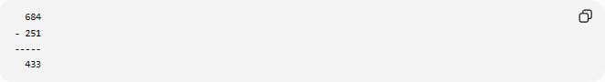
684
- 251
-----
433
Steps:
- Align the numbers according to their place values.
- Subtract the ones column.
- Subtract the tens column.
- Subtract the hundreds column.

Subtraction with Borrowing (Regrouping)
# Source: AI Source: Provided by: [Data Path: Persons Table -> ID Column: 1, Name_En Column: Motasem Essam] -> From: [ChatGPT] on [7/11/2026]
Example:
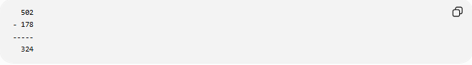
502
- 178
-----
324
Step-by-step:
- Ones:
Since $2<8$, borrow 1 ten.
The tens digit is 0, so borrow from the hundreds place first.
After regrouping:
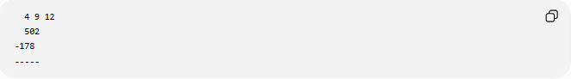
4 9 12
502
-178
-----
Now subtract:
- Ones:
$$12-8=4$$
- Tens:
$$9-7=2$$
- Hundreds:
$$4-1=3$$
Result:
$$502-178=324$$

Properties of Subtraction

1. Not Closed
# Source: AI Source: Provided by: [Data Path: Persons Table -> ID Column: 1, Name_En Column: Motasem Essam] -> From: [ChatGPT] on [7/11/2026]
Whole numbers are not closed under subtraction because the result may be negative.
Example:
$$4-9=-5$$
Since $-5$is not a whole number, subtraction is not closed.

2. Not Commutative
# Source: AI Source: Provided by: [Data Path: Persons Table -> ID Column: 1, Name_En Column: Motasem Essam] -> From: [ChatGPT] on [7/11/2026]
Changing the order changes the result.
$$a-b≠b-a$$
Example:
$$12-5=7$$
but
$$5-12=-7$$
Therefore,
$$12-5≠5-12$$

3. Not Associative
# Source: AI Source: Provided by: [Data Path: Persons Table -> ID Column: 1, Name_En Column: Motasem Essam] -> From: [ChatGPT] on [7/11/2026]
Changing the grouping changes the result.
$$\left(a-b)-c≠a-(b-c\right)$$
Example:
$$(15-5)-2=8$$
but
$$15-(5-2)=12$$
Therefore, subtraction is not associative.

4. Identity Property
# Source: AI Source: Provided by: [Data Path: Persons Table -> ID Column: 1, Name_En Column: Motasem Essam] -> From: [ChatGPT] on [7/11/2026]
Subtracting zero leaves the number unchanged.
$$a-0=a$$
Example:
$$42-0=42$$
However,
$$0-a≠a$$
for any positive whole number $a$.

Checking Subtraction
# Source: AI Source: Provided by: [Data Path: Persons Table -> ID Column: 1, Name_En Column: Motasem Essam] -> From: [ChatGPT] on [7/11/2026]
Subtraction can be verified using addition.
Example:
$$84-29=55$$
Check:
$$55+29=84$$
Since the original number is obtained, the subtraction is correct.

Real-Life Applications
# Source: AI Source: Provided by: [Data Path: Persons Table -> ID Column: 1, Name_En Column: Motasem Essam] -> From: [ChatGPT] on [7/11/2026]
Subtraction of whole numbers is used in:
- Finding change after shopping.
- Calculating the remaining quantity.
- Determining age differences.
- Measuring distances between locations.
- Inventory management.
- Keeping score in games.
- Budgeting and expense tracking.

Real-Life Examples
# Source: AI Source: Provided by: [Data Path: Persons Table -> ID Column: 1, Name_En Column: Motasem Essam] -> From: [ChatGPT] on [7/11/2026]
1. Shopping Change
A customer buys an item costing 75 dollars and pays with 100 dollars.
Change received:
$$100-75=25$$
The customer receives 25 dollars in change.

2. Books Remaining
A library has 250 books on a shelf.
If 48 books are borrowed:
$$250-48=202$$
There are 202 books remaining.

3. Students Absent
A class has 35 students.
If 4 students are absent:
$$35-4=31$$
There are 31 students present.

4. Fuel Remaining
A car's fuel tank contains 60 liters.
After using 18 liters:
$$60-18=42$$
There are 42 liters of fuel remaining.

5. Saving Money
Ahmed has 500 dollars in his savings account.
He withdraws 175 dollars.
Remaining balance:
$$500-175=325$$
Ahmed has 325 dollars left.

6. Distance Remaining
A traveler plans to drive 450 km.
After driving 185 km:
$$450-185=265\text{ km}$$
There are 265 km remaining.

7. Inventory
A store has 800 bottles in stock.
It sells 235 bottles.
Remaining inventory:
$$800-235=565$$
The store has 565 bottles remaining.

8. Game Score Difference
Team A scores 92 points.
Team B scores 84 points.
Difference in score:
$$92-84=8$$
Team A wins by 8 points.

Common Mistakes
# Source: AI Source: Provided by: [Data Path: Persons Table -> ID Column: 1, Name_En Column: Motasem Essam] -> From: [ChatGPT] on [7/11/2026]
- Forgetting to borrow (regroup) when necessary.
- Borrowing from the wrong place-value column.
- Misaligning digits according to place value.
- Assuming subtraction is commutative.

Key Points
# Source: AI Source: Provided by: [Data Path: Persons Table -> ID Column: 1, Name_En Column: Motasem Essam] -> From: [ChatGPT] on [7/11/2026]
- Subtraction finds the difference between two whole numbers.
- The symbol for subtraction is −.
- The result is called the difference.
- Whole numbers are not closed under subtraction.
- Subtraction is not commutative.
- Subtraction is not associative.
- Subtracting zero leaves a number unchanged.
- Addition can be used to check subtraction.

Whole Number Addition vs. Subtraction
# Source: AI Source: Provided by: [Data Path: Persons Table -> ID Column: 1, Name_En Column: Motasem Essam] -> From: [ChatGPT] on [7/11/2026]
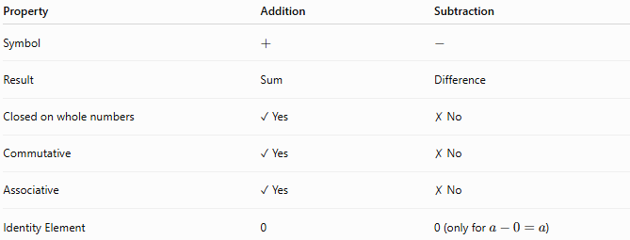
Property | Addition | Subtraction
Symbol | $$+$$ | $$-$$
Result | Sum | Difference
Closed on whole numbers | ✓ Yes | ✗ No
Commutative | ✓ Yes | ✗ No
Associative | ✓ Yes | ✗ No
Identity Element | 0 | 0 (only for $a-0=a$)

Conclusion
# Source: AI Source: Provided by: [Data Path: Persons Table -> ID Column: 1, Name_En Column: Motasem Essam] -> From: [ChatGPT] on [7/11/2026]
Subtraction is the arithmetic operation used to find the difference between two whole numbers by removing one quantity from another. It is essential for comparing quantities, determining what remains, and solving everyday problems. Unlike addition, subtraction is not closed, not commutative, and not associative on the set of whole numbers, making careful attention to order and regrouping important when performing subtraction.

Multiplication
# Source: AI Source: Provided by: [Data Path: Persons Table -> ID Column: 1, Name_En Column: Motasem Essam] -> From: [ChatGPT] on [7/11/2026]
Multiplication is one of the four basic arithmetic operations. It is the process of combining equal groups of a whole number or repeatedly adding the same number to find the total.
Whole number multiplication is widely used in mathematics and everyday life for counting equal groups, calculating areas, determining costs, and solving many practical problems.

Definition
# Source: AI Source: Provided by: [Data Path: Persons Table -> ID Column: 1, Name_En Column: Motasem Essam] -> From: [ChatGPT] on [7/11/2026]
Multiplication is the arithmetic operation of finding the product of two or more whole numbers by repeated addition or by combining equal groups.
Mathematically:
$$a×b=c$$
where:
- $a$is the multiplicand (the number being multiplied).
- $b$is the multiplier (the number of times the multiplicand is taken).
- $c$is the product (the result of multiplication).

Multiplication Symbols
# Source: AI Source: Provided by: [Data Path: Persons Table -> ID Column: 1, Name_En Column: Motasem Essam] -> From: [ChatGPT] on [7/11/2026]
Common symbols for multiplication include:
$$×,⋅,(*)$$
Examples:
$$6×4=24 \\ 6⋅4=24$$

Multiplication as Repeated Addition
# Source: AI Source: Provided by: [Data Path: Persons Table -> ID Column: 1, Name_En Column: Motasem Essam] -> From: [ChatGPT] on [7/11/2026]
Multiplication can be viewed as repeated addition.
Example:
$$5×4$$
means adding 5 four times:
$$5+5+5+5=20$$
Therefore,
$$5×4=20$$

Examples
# Source: AI Source: Provided by: [Data Path: Persons Table -> ID Column: 1, Name_En Column: Motasem Essam] -> From: [ChatGPT] on [7/11/2026]
Example 1
Multiply:
$$7×3$$
Solution:
$$21$$

Example 2
Multiply:
$$12×8$$
Solution:
$$96$$

Example 3
Multiply:
$$25×16$$
Solution:
$$400$$

Example 4
Multiply three whole numbers:
$$4×5×3$$
Solution:
$$4×5=20 \\ 20×3=60$$
Therefore,
$$4×5×3=60$$

Vertical Multiplication
# Source: AI Source: Provided by: [Data Path: Persons Table -> ID Column: 1, Name_En Column: Motasem Essam] -> From: [ChatGPT] on [7/11/2026]
Example:
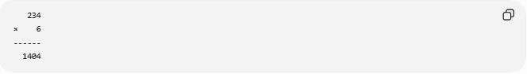
234
× 6
------
1404
Calculation:
$$234×6=1404$$

Example with Two-Digit Multiplier
# Source: AI Source: Provided by: [Data Path: Persons Table -> ID Column: 1, Name_En Column: Motasem Essam] -> From: [ChatGPT] on [7/11/2026]
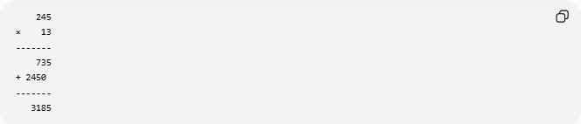
245
× 13
-------
735
+ 2450
-------
3185
Therefore,
$$245×13=3185$$

Multiplication Table (1–10)
# Source: AI Source: Provided by: [Data Path: Persons Table -> ID Column: 1, Name_En Column: Motasem Essam] -> From: [ChatGPT] on [7/11/2026]
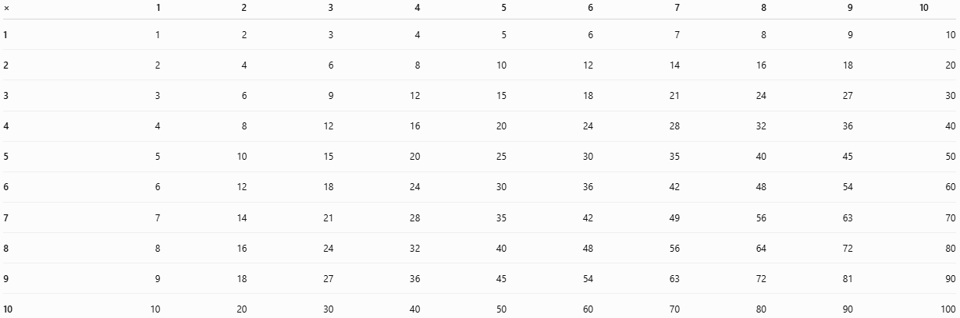
× | 1 | 2 | 3 | 4 | 5 | 6 | 7 | 8 | 9 | 10
1 | 1 | 2 | 3 | 4 | 5 | 6 | 7 | 8 | 9 | 10
2 | 2 | 4 | 6 | 8 | 10 | 12 | 14 | 16 | 18 | 20
3 | 3 | 6 | 9 | 12 | 15 | 18 | 21 | 24 | 27 | 30
4 | 4 | 8 | 12 | 16 | 20 | 24 | 28 | 32 | 36 | 40
5 | 5 | 10 | 15 | 20 | 25 | 30 | 35 | 40 | 45 | 50
6 | 6 | 12 | 18 | 24 | 30 | 36 | 42 | 48 | 54 | 60
7 | 7 | 14 | 21 | 28 | 35 | 42 | 49 | 56 | 63 | 70
8 | 8 | 16 | 24 | 32 | 40 | 48 | 56 | 64 | 72 | 80
9 | 9 | 18 | 27 | 36 | 45 | 54 | 63 | 72 | 81 | 90
10 | 10 | 20 | 30 | 40 | 50 | 60 | 70 | 80 | 90 | 100

Properties of Multiplication

1. Closure Property
# Source: AI Source: Provided by: [Data Path: Persons Table -> ID Column: 1, Name_En Column: Motasem Essam] -> From: [ChatGPT] on [7/11/2026]
The product of two whole numbers is always a whole number.
$$a,b∈W⇒a×b∈W$$
Example:
$$14×5=70$$

2. Commutative Property
# Source: AI Source: Provided by: [Data Path: Persons Table -> ID Column: 1, Name_En Column: Motasem Essam] -> From: [ChatGPT] on [7/11/2026]
Changing the order does not change the product.
$$a×b=b×a$$
Example:
$$8×6=6×8=48$$

3. Associative Property
# Source: AI Source: Provided by: [Data Path: Persons Table -> ID Column: 1, Name_En Column: Motasem Essam] -> From: [ChatGPT] on [7/11/2026]
Changing the grouping does not change the product.
$$\left(a×b)×c=a×(b×c\right)$$
Example:
$$(2×5)×4=2×(5×4)=40$$

4. Identity Property
# Source: AI Source: Provided by: [Data Path: Persons Table -> ID Column: 1, Name_En Column: Motasem Essam] -> From: [ChatGPT] on [7/11/2026]
The multiplicative identity is 1.
$$a×1=a$$
Example:
$$73×1=73$$

5. Zero Property
# Source: AI Source: Provided by: [Data Path: Persons Table -> ID Column: 1, Name_En Column: Motasem Essam] -> From: [ChatGPT] on [7/11/2026]
Any whole number multiplied by zero equals zero.
$$a×0=0$$
Example:
$$95×0=0$$

6. Distributive Property
# Source: AI Source: Provided by: [Data Path: Persons Table -> ID Column: 1, Name_En Column: Motasem Essam] -> From: [ChatGPT] on [7/11/2026]
Multiplication distributes over addition.
$$a(b+c)=ab+ac$$
Example:
$$7(8+2)=7×8+7×2=56+14=70$$

Real-Life Applications
# Source: AI Source: Provided by: [Data Path: Persons Table -> ID Column: 1, Name_En Column: Motasem Essam] -> From: [ChatGPT] on [7/11/2026]
Multiplication of whole numbers is used in:
- Calculating the total cost of multiple identical items
- Finding the area of rectangles
- Counting equal groups of objects
- Inventory management
- Payroll calculations
- Manufacturing and production
- Seating arrangements
- Scheduling repeated events

Real-Life Examples
# Source: AI Source: Provided by: [Data Path: Persons Table -> ID Column: 1, Name_En Column: Motasem Essam] -> From: [ChatGPT] on [7/11/2026]
1. Shopping
A notebook costs 12 dollars.
If Ahmed buys 5 notebooks:
$$12×5=60$$
Ahmed pays 60 dollars.

2. Classroom Chairs
There are 8 rows of chairs with 6 chairs in each row.
Total chairs:
$$8×6=48$$
There are 48 chairs.

3. Area of a Rectangle
A garden is 15 m long and 8 m wide.
Area:
$$15×8=120{\text{ m}}^{2}$$
The garden covers 120 square meters.

4. Fruit Boxes
Each box contains 24 apples.
If there are 9 boxes:
$$24×9=216$$
There are 216 apples.

5. Weekly Earnings
A worker earns 80 dollars per day for 5 days.
Total earnings:
$$80×5=400$$
The worker earns 400 dollars.

6. School Buses
Each school bus carries 45 students.
If 12 buses are used:
$$45×12=540$$
The buses can carry 540 students.

7. Brick Wall
A wall has 18 rows of bricks with 25 bricks in each row.
Total bricks:
$$18×25=450$$
The wall contains 450 bricks.

8. Movie Theater
A theater has 20 rows with 18 seats in each row.
Total seats:
$$20×18=360$$
The theater has 360 seats.

Common Mistakes
# Source: AI Source: Provided by: [Data Path: Persons Table -> ID Column: 1, Name_En Column: Motasem Essam] -> From: [ChatGPT] on [7/11/2026]
- Forgetting to multiply by every digit in long multiplication.
- Misaligning partial products.
- Forgetting to add a placeholder zero when multiplying by the tens place.
- Confusing multiplication with repeated addition when groups are unequal.

Key Points
# Source: AI Source: Provided by: [Data Path: Persons Table -> ID Column: 1, Name_En Column: Motasem Essam] -> From: [ChatGPT] on [7/11/2026]
- Multiplication combines equal groups or represents repeated addition.
- The result of multiplication is called the product.
- Whole numbers are closed under multiplication.
- Multiplication satisfies the closure, commutative, associative, identity, zero, and distributive properties.
- Multiplying any whole number by 1 leaves it unchanged.
- Multiplying any whole number by 0 always results in 0.

Whole Number Addition vs. Multiplication
# Source: AI Source: Provided by: [Data Path: Persons Table -> ID Column: 1, Name_En Column: Motasem Essam] -> From: [ChatGPT] on [7/11/2026]
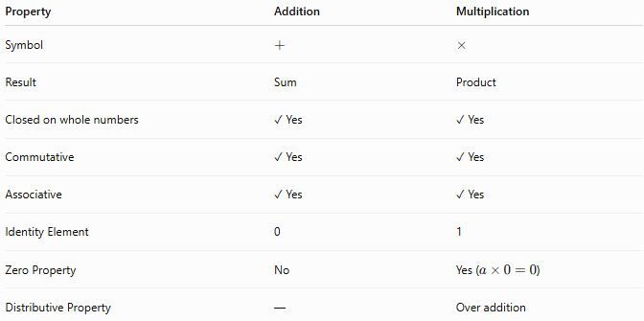
Property | Addition | Multiplication
Symbol | $$+$$ | $$×$$
Result | Sum | Product
Closed on whole numbers | ✓ Yes | ✓ Yes
Commutative | ✓ Yes | ✓ Yes
Associative | ✓ Yes | ✓ Yes
Identity Element | 0 | 1
Zero Property | No | Yes ($a×0=0$)
Distributive Property | — | Over addition

Conclusion
# Source: AI Source: Provided by: [Data Path: Persons Table -> ID Column: 1, Name_En Column: Motasem Essam] -> From: [ChatGPT] on [7/11/2026]
Multiplication is the arithmetic operation used to combine equal groups or perform repeated addition of whole numbers. It is fundamental in mathematics and countless real-world applications, including measurement, finance, geometry, and science. Whole number multiplication always produces another whole number and obeys important mathematical properties such as closure, commutativity, associativity, the identity property, the zero property, and the distributive property, making it an essential tool for mathematical reasoning and problem-solving.

Division
# Source: AI Source: Provided by: [Data Path: Persons Table -> ID Column: 1, Name_En Column: Motasem Essam] -> From: [ChatGPT] on [7/11/2026]
Division is one of the four basic arithmetic operations. It is the process of splitting a whole number into equal parts or determining how many times one whole number is contained in another.
Whole number division is the inverse operation of multiplication and is widely used in mathematics and everyday life for sharing, grouping, measuring, and solving practical problems.

Definition
# Source: AI Source: Provided by: [Data Path: Persons Table -> ID Column: 1, Name_En Column: Motasem Essam] -> From: [ChatGPT] on [7/11/2026]
Division is the arithmetic operation of separating a quantity into equal groups or finding the number of equal groups.
Mathematically:
$$a÷b=q$$
or
$$\frac{a}{b}=q$$
where:
- $a$is the dividend (the number being divided).
- $b$is the divisor (the number by which the dividend is divided).
- $q$is the quotient (the result of the division).
If the division is not exact, there may also be a remainder $r$.
$$a=bq+r$$
where
$$0≤r<b$$

Division Symbols
# Source: AI Source: Provided by: [Data Path: Persons Table -> ID Column: 1, Name_En Column: Motasem Essam] -> From: [ChatGPT] on [7/11/2026]
Common symbols for division include:
$$÷,/,\frac{a}{b}$$
Example:
$$20÷5=4$$
or
$$20/5=4$$

Division as the Inverse of Multiplication
# Source: AI Source: Provided by: [Data Path: Persons Table -> ID Column: 1, Name_En Column: Motasem Essam] -> From: [ChatGPT] on [7/11/2026]
Division "undoes" multiplication.
Example:
$$6×7=42$$
Therefore,
$$42÷7=6$$
and
$$42÷6=7$$

Examples
# Source: AI Source: Provided by: [Data Path: Persons Table -> ID Column: 1, Name_En Column: Motasem Essam] -> From: [ChatGPT] on [7/11/2026]
Example 1
Divide:
$$24÷6$$
Solution:
$$24÷6=4$$

Example 2
Divide:
$$81÷9$$
Solution:
$$81÷9=9$$

Example 3
Divide:
$$96÷8$$
Solution:
$$96÷8=12$$

Example 4
Divide with a remainder:
$$35÷6$$
Solution:
$$35=6×5+5$$
Therefore,
- Quotient = 5
- Remainder = 5

Long Division
# Source: AI Source: Provided by: [Data Path: Persons Table -> ID Column: 1, Name_En Column: Motasem Essam] -> From: [ChatGPT] on [7/11/2026]
Example:
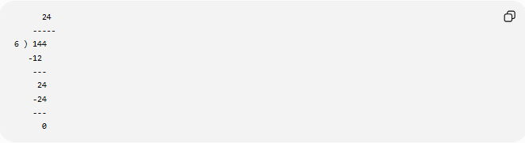
24
-----
6 ) 144
-12
---
24
-24
---
0
Therefore,
$$144÷6=24$$

Division with a Remainder
# Source: AI Source: Provided by: [Data Path: Persons Table -> ID Column: 1, Name_En Column: Motasem Essam] -> From: [ChatGPT] on [7/11/2026]
Example:
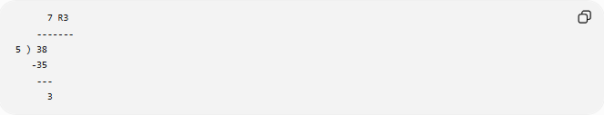
7 R3
-------
5 ) 38
-35
---
3
Therefore,
$$38÷5=7\text{ remainder }3$$

Properties of Division

1. Not Closed
# Source: AI Source: Provided by: [Data Path: Persons Table -> ID Column: 1, Name_En Column: Motasem Essam] -> From: [ChatGPT] on [7/11/2026]
Whole numbers are not closed under division because the quotient may not be a whole number.
$$a,b∈W, b≠0⇏a÷b∈W$$
Example:
$$7÷2=3.5$$
Since 3.5 is not a whole number, division is not closed.

2. Not Commutative
# Source: AI Source: Provided by: [Data Path: Persons Table -> ID Column: 1, Name_En Column: Motasem Essam] -> From: [ChatGPT] on [7/11/2026]
Changing the order changes the result.
$$a÷b≠b÷a$$
Example:
$$12÷3=4$$
but
$$3÷12=\frac{1}{4}$$
Therefore,
$$12÷3≠3÷12$$

3. Not Associative
# Source: AI Source: Provided by: [Data Path: Persons Table -> ID Column: 1, Name_En Column: Motasem Essam] -> From: [ChatGPT] on [7/11/2026]
Changing the grouping changes the result.
$$\left(a÷b)÷c≠a÷(b÷c\right)$$
Example:
$$(24÷6)÷2=2$$
but
$$24÷(6÷2)=8$$
Therefore, division is not associative.

4. Identity Property
# Source: AI Source: Provided by: [Data Path: Persons Table -> ID Column: 1, Name_En Column: Motasem Essam] -> From: [ChatGPT] on [7/11/2026]
Dividing a whole number by 1 leaves it unchanged.
$$a÷1=a$$
Example:
$$75÷1=75$$

5. Division by Zero
# Source: AI Source: Provided by: [Data Path: Persons Table -> ID Column: 1, Name_En Column: Motasem Essam] -> From: [ChatGPT] on [7/11/2026]
Division by zero is undefined.
$$a÷0$$
has no meaning in mathematics.
Examples:
$$12÷0$$
Undefined
$$0÷0$$
Also undefined.

6. Zero Dividend Property
# Source: AI Source: Provided by: [Data Path: Persons Table -> ID Column: 1, Name_En Column: Motasem Essam] -> From: [ChatGPT] on [7/11/2026]
Zero divided by any nonzero whole number equals zero.
$$0÷a=0(a≠0)$$
Example:
$$0÷9=0$$

Checking Division
# Source: AI Source: Provided by: [Data Path: Persons Table -> ID Column: 1, Name_En Column: Motasem Essam] -> From: [ChatGPT] on [7/11/2026]
Division can be verified using multiplication.
Example:
$$72÷8=9$$
Check:
$$9×8=72$$
Since the original dividend is obtained, the division is correct.

Real-Life Applications
# Source: AI Source: Provided by: [Data Path: Persons Table -> ID Column: 1, Name_En Column: Motasem Essam] -> From: [ChatGPT] on [7/11/2026]
Division of whole numbers is used in:
- Sharing items equally
- Calculating unit prices
- Determining averages
- Packaging products into equal groups
- Scheduling work among people
- Dividing distances into equal segments
- Inventory distribution
- Resource allocation

Real-Life Examples
# Source: AI Source: Provided by: [Data Path: Persons Table -> ID Column: 1, Name_En Column: Motasem Essam] -> From: [ChatGPT] on [7/11/2026]
1. Sharing Apples
There are 24 apples shared equally among 6 children.
Each child receives:
$$24÷6=4$$
Each child gets 4 apples.

2. Packaging Bottles
A factory has 180 bottles.
They are packed into boxes holding 12 bottles each.
Number of boxes:
$$180÷12=15$$
The factory fills 15 boxes.

3. Classroom Groups
A teacher divides 32 students into groups of 4.
Number of groups:
$$32÷4=8$$
There are 8 groups.

4. Traveling Distance
A car travels 360 km in 6 hours.
Average distance per hour:
$$360÷6=60\text{ km/h}$$
The average speed is 60 km/h.

5. Weekly Salary
A worker earns 700 dollars in 7 days.
Daily earnings:
$$700÷7=100$$
The worker earns 100 dollars per day.

6. Library Shelves
A library has 240 books.
The books are placed equally on 8 shelves.
Books per shelf:
$$240÷8=30$$
Each shelf contains 30 books.

7. Pizza Sharing
A pizza is cut into 8 equal slices.
If 4 friends share all the slices equally:
$$8÷4=2$$
Each friend receives 2 slices.

8. Inventory Distribution
A warehouse has 540 boxes to distribute equally among 9 stores.
Boxes per store:
$$540÷9=60$$
Each store receives 60 boxes.

Common Mistakes
# Source: AI Source: Provided by: [Data Path: Persons Table -> ID Column: 1, Name_En Column: Motasem Essam] -> From: [ChatGPT] on [7/11/2026]
- Dividing by zero.
- Forgetting to write the remainder when the division is not exact.
- Misplacing digits during long division.
- Assuming division is commutative or associative.
- Confusing the dividend and the divisor.

Key Points
# Source: AI Source: Provided by: [Data Path: Persons Table -> ID Column: 1, Name_En Column: Motasem Essam] -> From: [ChatGPT] on [7/11/2026]
- Division separates a quantity into equal groups or determines how many equal groups can be formed.
- The result of division is called the quotient.
- If the division is not exact, a remainder may occur.
- Whole numbers are not closed under division.
- Division is not commutative.
- Division is not associative.
- Dividing by 1 leaves a number unchanged.
- Dividing by 0 is undefined.
- Multiplication can be used to check division.

Whole Number Multiplication vs. Division
# Source: AI Source: Provided by: [Data Path: Persons Table -> ID Column: 1, Name_En Column: Motasem Essam] -> From: [ChatGPT] on [7/11/2026]
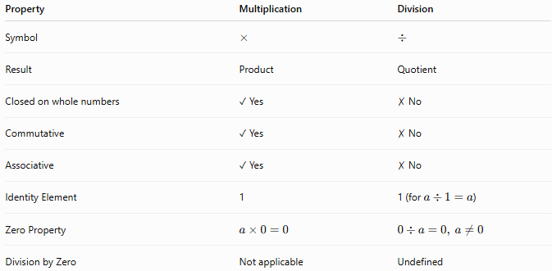
Property | Multiplication | Division
Symbol | $$×$$ | $$÷$$
Result | Product | Quotient
Closed on whole numbers | ✓ Yes | ✗ No
Commutative | ✓ Yes | ✗ No
Associative | ✓ Yes | ✗ No
Identity Element | 1 | 1 (for $a÷1=a$)
Zero Property | $$a×0=0$$ | $$0÷a=0, a≠0$$
Division by Zero | Not applicable | Undefined

Conclusion
# Source: AI Source: Provided by: [Data Path: Persons Table -> ID Column: 1, Name_En Column: Motasem Essam] -> From: [ChatGPT] on [7/11/2026]
Division is the arithmetic operation used to separate whole numbers into equal groups or determine how many times one number is contained within another. It is the inverse of multiplication and plays an essential role in mathematics and everyday life. Unlike multiplication, division is not closed, not commutative, and not associative on the set of whole numbers. Understanding division, remainders, and the fact that division by zero is undefined is fundamental for solving mathematical problems accurately.

Modulus
# Source: AI Source: Provided by: [Data Path: Persons Table -> ID Column: 1, Name_En Column: Motasem Essam] -> From: [ChatGPT] on [7/11/2026]
Modulus (also called the modulo operation) is an arithmetic operation that returns the remainder after dividing one whole number by another.
The modulus operation is widely used in mathematics, computer science, cryptography, number theory, programming, and digital systems.

Definition
# Source: AI Source: Provided by: [Data Path: Persons Table -> ID Column: 1, Name_En Column: Motasem Essam] -> From: [ChatGPT] on [7/11/2026]
The modulus of two whole numbers is the remainder obtained after performing integer division.
Mathematically,
$$a mod b=r$$
where:
- $a$is the dividend.
- $b$is the divisor ($b≠0$).
- $r$is the remainder.
The remainder satisfies:
$$0≤r<b$$
and
$$a=bq+r$$
where:
- $q$is the quotient
- $r$is the remainder

Modulus Symbols
# Source: AI Source: Provided by: [Data Path: Persons Table -> ID Column: 1, Name_En Column: Motasem Essam] -> From: [ChatGPT] on [7/11/2026]
The modulus operation is commonly written as:
$$a mod b$$
or in programming:
a % b
Examples:
$$17 mod 5=2$$
because
$$17=5×3+2$$

Modulus as the Remainder of Division
# Source: AI Source: Provided by: [Data Path: Persons Table -> ID Column: 1, Name_En Column: Motasem Essam] -> From: [ChatGPT] on [7/11/2026]
The modulus operation returns only the remainder of a division.
Example:
$$23÷6=3\text{ remainder }5$$
Therefore,
$$23 mod 6=5$$
Similarly,
$$40÷8=5$$
Since the division is exact,
$$40 mod 8=0$$

Examples
# Source: AI Source: Provided by: [Data Path: Persons Table -> ID Column: 1, Name_En Column: Motasem Essam] -> From: [ChatGPT] on [7/11/2026]
Example 1
Find:
$$15 mod 4$$
Solution:
$$15=4×3+3$$
Therefore,
$$15 mod 4=3$$

Example 2
Find:
$$28 mod 7$$
Solution:
$$28=7×4+0$$
Therefore,
$$28 mod 7=0$$

Example 3
Find:
$$35 mod 6$$
Solution:
$$35=6×5+5$$
Therefore,
$$35 mod 6=5$$

Example 4
Find:
$$100 mod 9$$
Solution:
$$100=9×11+1$$
Therefore,
$$100 mod 9=1$$

Modulus Table (Modulo 5)
# Source: AI Source: Provided by: [Data Path: Persons Table -> ID Column: 1, Name_En Column: Motasem Essam] -> From: [ChatGPT] on [7/11/2026]
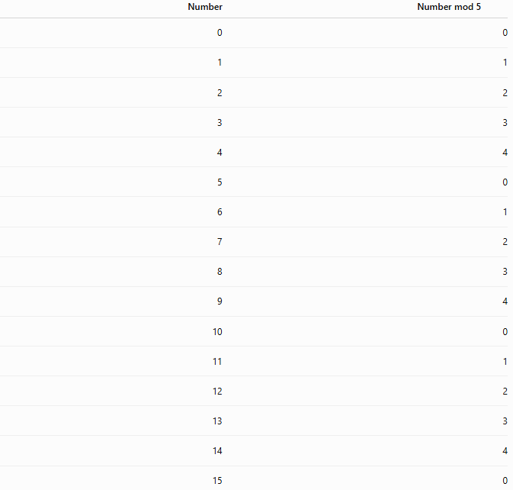
Number | Number mod 5
0 | 0
1 | 1
2 | 2
3 | 3
4 | 4
5 | 0
6 | 1
7 | 2
8 | 3
9 | 4
10 | 0
11 | 1
12 | 2
13 | 3
14 | 4
15 | 0

Properties of Modulus
Let $a$, $b$, and $n$be whole numbers with $n>0$.

1. Range of the Result
# Source: AI Source: Provided by: [Data Path: Persons Table -> ID Column: 1, Name_En Column: Motasem Essam] -> From: [ChatGPT] on [7/11/2026]
The remainder is always less than the divisor.
$$0≤a mod n<n$$
Example:
$$23 mod 7=2$$
where
$$0≤2<7$$

2. Divisibility Property
# Source: AI Source: Provided by: [Data Path: Persons Table -> ID Column: 1, Name_En Column: Motasem Essam] -> From: [ChatGPT] on [7/11/2026]
If a number is divisible by another number,
$$a mod b=0$$
Example:
$$36 mod 6=0$$

3. Identity Property
# Source: AI Source: Provided by: [Data Path: Persons Table -> ID Column: 1, Name_En Column: Motasem Essam] -> From: [ChatGPT] on [7/11/2026]
If the dividend is smaller than the divisor,
$$a mod b=a$$
when
$$a<b$$
Example:
$$4 mod 9=4$$

4. Modulus by One
Every whole number divided by one leaves remainder zero.
$$a mod 1=0$$
Example:
$$57 mod 1=0$$

5. Modulus by Itself
# Source: AI Source: Provided by: [Data Path: Persons Table -> ID Column: 1, Name_En Column: Motasem Essam] -> From: [ChatGPT] on [7/11/2026]
Every positive whole number divided by itself leaves remainder zero.
$$a mod a=0$$
Example:
$$25 mod 25=0$$

6. Modulus by Zero
# Source: AI Source: Provided by: [Data Path: Persons Table -> ID Column: 1, Name_En Column: Motasem Essam] -> From: [ChatGPT] on [7/11/2026]
Modulus by zero is undefined.
$$a mod 0$$
has no mathematical meaning.

Relationship Between Division and Modulus
# Source: AI Source: Provided by: [Data Path: Persons Table -> ID Column: 1, Name_En Column: Motasem Essam] -> From: [ChatGPT] on [7/11/2026]
For every whole-number division,
$$a=bq+r$$
where
$$r=a mod b$$
Example:
$$29=6×4+5$$
Therefore,
- Quotient = 4
- Remainder = 5
and
$$29 mod 6=5$$

Real-Life Applications
# Source: AI Source: Provided by: [Data Path: Persons Table -> ID Column: 1, Name_En Column: Motasem Essam] -> From: [ChatGPT] on [7/11/2026]
The modulus operation is used in:
- Determining even and odd numbers
- Digital clocks and calendars
- Circular counting
- Computer programming
- Cryptography
- Hash functions
- Scheduling repeated events
- Number theory

Real-Life Examples
# Source: AI Source: Provided by: [Data Path: Persons Table -> ID Column: 1, Name_En Column: Motasem Essam] -> From: [ChatGPT] on [7/11/2026]
1. Even or Odd Numbers
To determine whether a number is even:
$$n mod 2$$
Example:
$$14 mod 2=0$$
Therefore, 14 is even.
Example:
$$15 mod 2=1$$
Therefore, 15 is odd.

2. Digital Clock
A clock repeats every 12 hours.
After 15 hours:
$$15 mod 12=3$$
The clock shows 3 o'clock.

3. Days of the Week
The days repeat every 7 days.
After 20 days:
$$20 mod 7=6$$
The day advances by 6 days.

4. Classroom Groups
Thirty students are divided into groups of 8.
$$30 mod 8=6$$
Six students remain after forming complete groups.

5. Computer Programming
Programmers use
number % 2
to determine whether a number is even or odd.

6. Circular Seating
Twenty-three participants sit around a circular table with 10 seats.
$$23 mod 10=3$$
Counting wraps around to seat 3.

7. Leap-Year Calculations
Calendar algorithms use modulus to determine leap years by checking divisibility conditions.

8. Cryptography
Encryption algorithms such as RSA perform arithmetic using modular operations.

Common Mistakes
# Source: AI Source: Provided by: [Data Path: Persons Table -> ID Column: 1, Name_En Column: Motasem Essam] -> From: [ChatGPT] on [7/11/2026]
- Confusing division with modulus.
- Forgetting that modulus returns the remainder, not the quotient.
- Using modulus with a divisor of zero, which is undefined.
- Assuming modulus is the same as a fraction.
- Confusing the % operator with the percentage symbol %.

Key Points
# Source: AI Source: Provided by: [Data Path: Persons Table -> ID Column: 1, Name_En Column: Motasem Essam] -> From: [ChatGPT] on [7/11/2026]
- Modulus returns the remainder after integer division.
- It is written as mod or % in programming.
- The remainder is always between 0 and divisor − 1.
- If the remainder is 0, the dividend is divisible by the divisor.
- Modulus by 0 is undefined.
- Modulus is widely used in programming, cryptography, calendars, clocks, and number theory.

Whole Number Division vs. Modulus
# Source: AI Source: Provided by: [Data Path: Persons Table -> ID Column: 1, Name_En Column: Motasem Essam] -> From: [ChatGPT] on [7/11/2026]
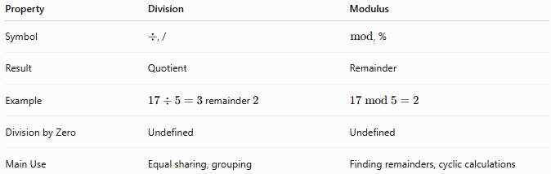
Property | Division | Modulus
Symbol | $÷$, / | $mod$, %
Result | Quotient | Remainder
Example | $17÷5=3$remainder $2$ | $$17 mod 5=2$$
Division by Zero | Undefined | Undefined
Main Use | Equal sharing, grouping | Finding remainders, cyclic calculations

Conclusion
# Source: AI Source: Provided by: [Data Path: Persons Table -> ID Column: 1, Name_En Column: Motasem Essam] -> From: [ChatGPT] on [7/11/2026]
Modulus (Modulo) is the arithmetic operation that returns the remainder after dividing one whole number by another. It is closely related to division but focuses only on the remainder rather than the quotient. Modulus is fundamental in mathematics, computer science, number theory, cryptography, and many real-world applications involving cyclic patterns, divisibility, and repeated sequences.

Exponentiation (Power)
# Source: AI Source: Provided by: [Data Path: Persons Table -> ID Column: 1, Name_En Column: Motasem Essam] -> From: [ChatGPT] on [7/11/2026]
Exponentiation (also called raising to a power) is an arithmetic operation in which a whole number, called the base, is multiplied by itself a specified number of times.
Exponentiation provides a concise way to write repeated multiplication and is widely used in mathematics, science, engineering, computer science, and finance.

Definition
# Source: AI Source: Provided by: [Data Path: Persons Table -> ID Column: 1, Name_En Column: Motasem Essam] -> From: [ChatGPT] on [7/11/2026]
Exponentiation is the arithmetic operation of repeatedly multiplying a number by itself.
Mathematically:
$$a^{n}$$
where:
- $a$is the base.
- $n$is the exponent (or power).
- $a^{n}$is called the power.
For a nonnegative integer exponent:
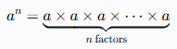
$$a^{n}=\underset{n\text{ factors}}{\underset{⏟}{a×a×a×⋯×a}}$$

Exponentiation Symbols
# Source: AI Source: Provided by: [Data Path: Persons Table -> ID Column: 1, Name_En Column: Motasem Essam] -> From: [ChatGPT] on [7/11/2026]
Exponentiation is commonly written using:
$$a^{n}$$
or in programming:
a**n
Example:
$$5^{3}=125$$

Exponentiation as Repeated Multiplication
# Source: AI Source: Provided by: [Data Path: Persons Table -> ID Column: 1, Name_En Column: Motasem Essam] -> From: [ChatGPT] on [7/11/2026]
Exponentiation represents repeated multiplication.
Example:
$$4^{3}$$
means
$$4×4×4=64$$
Similarly,
$$2^{5}=2×2×2×2×2=32$$

Examples
# Source: AI Source: Provided by: [Data Path: Persons Table -> ID Column: 1, Name_En Column: Motasem Essam] -> From: [ChatGPT] on [7/11/2026]
Example 1
Evaluate:
$$3^{2}$$
Solution:
$$3×3=9$$

Example 2
Evaluate:
$$5^{3}$$
Solution:
$$5×5×5=125$$

Example 3
Evaluate:
$${10}^{4}$$
Solution:
$$10×10×10×10=10, \text{⁣}000$$

Example 4
Evaluate:
$$7^{1}$$
Solution:
$$7^{1}=7$$

Example 5
Evaluate:
$$9^{0}$$
Solution:
Any nonzero number raised to the power of zero equals 1.
$$9^{0}=1$$

Common Powers
# Source: AI Source: Provided by: [Data Path: Persons Table -> ID Column: 1, Name_En Column: Motasem Essam] -> From: [ChatGPT] on [7/11/2026]
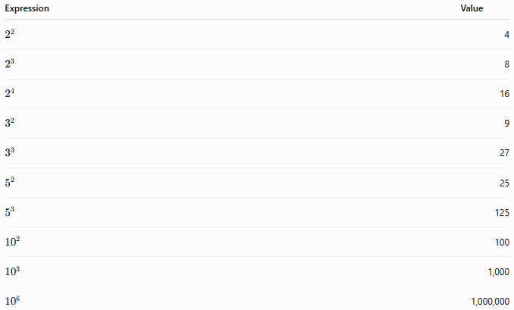
Expression | Value
$$2^{2}$$ | 4
$$2^{3}$$ | 8
$$2^{4}$$ | 16
$$3^{2}$$ | 9
$$3^{3}$$ | 27
$$5^{2}$$ | 25
$$5^{3}$$ | 125
$${10}^{2}$$ | 100
$${10}^{3}$$ | 1,000
$${10}^{6}$$ | 1,000,000

Special Cases

1. Exponent of One
# Source: AI Source: Provided by: [Data Path: Persons Table -> ID Column: 1, Name_En Column: Motasem Essam] -> From: [ChatGPT] on [7/11/2026]
Any whole number raised to the first power equals itself.
$$a^{1}=a$$
Example:
$${12}^{1}=12$$

2. Exponent of Zero
# Source: AI Source: Provided by: [Data Path: Persons Table -> ID Column: 1, Name_En Column: Motasem Essam] -> From: [ChatGPT] on [7/11/2026]
Any nonzero whole number raised to the zero power equals 1.
$$a^{0}=1(a≠0)$$
Example:
$$8^{0}=1$$
Note: $0^{0}$is generally considered undefined or indeterminate, depending on the mathematical context.

3. Zero as the Base
# Source: AI Source: Provided by: [Data Path: Persons Table -> ID Column: 1, Name_En Column: Motasem Essam] -> From: [ChatGPT] on [7/11/2026]
Zero raised to any positive whole-number exponent equals zero.
$$0^{n}=0(n>0)$$
Example:
$$0^{5}=0$$

4. Base of One
# Source: AI Source: Provided by: [Data Path: Persons Table -> ID Column: 1, Name_En Column: Motasem Essam] -> From: [ChatGPT] on [7/11/2026]
One raised to any whole-number exponent equals one.
$$1^{n}=1$$
Example:
$$1^{100}=1$$

Properties of Exponentiation
Let $a$and $b$be whole numbers, and let $m$and $n$be nonnegative integers.

1. Product of Powers
# Source: AI Source: Provided by: [Data Path: Persons Table -> ID Column: 1, Name_En Column: Motasem Essam] -> From: [ChatGPT] on [7/11/2026]
When multiplying powers with the same base, add the exponents.
$$a^{m}×a^{n}=a^{m+n}$$
Example:
$$2^{3}×2^{4}=2^{7}=128$$

2. Quotient of Powers
# Source: AI Source: Provided by: [Data Path: Persons Table -> ID Column: 1, Name_En Column: Motasem Essam] -> From: [ChatGPT] on [7/11/2026]
When dividing powers with the same base, subtract the exponents (provided the denominator is not zero).
$$\frac{a^{m}}{a^{n}}=a^{m-n}$$
Example:
$$\frac{5^{6}}{5^{2}}=5^{4}=625$$

3. Power of a Power
# Source: AI Source: Provided by: [Data Path: Persons Table -> ID Column: 1, Name_En Column: Motasem Essam] -> From: [ChatGPT] on [7/11/2026]
Multiply the exponents.
$$\left(a^{m})^{n} = a^{mn}\right.$$
Example:
$$\left(3^{2})^{4} = 3^{8} = 6561\right.$$

4. Power of a Product
# Source: AI Source: Provided by: [Data Path: Persons Table -> ID Column: 1, Name_En Column: Motasem Essam] -> From: [ChatGPT] on [7/11/2026]
Raise each factor to the exponent.
$$\left(ab)^{n} = a^{n}b^{n}\right.$$
Example:
$$\left(2×5)^{3}=2^{3}×5^{3}=8×125=1000\right.$$

5. Identity Property
# Source: AI Source: Provided by: [Data Path: Persons Table -> ID Column: 1, Name_En Column: Motasem Essam] -> From: [ChatGPT] on [7/11/2026]
The number 1 is unchanged by exponentiation.
$$1^{n}=1$$

Relationship Between Multiplication and Exponentiation
# Source: AI Source: Provided by: [Data Path: Persons Table -> ID Column: 1, Name_En Column: Motasem Essam] -> From: [ChatGPT] on [7/11/2026]
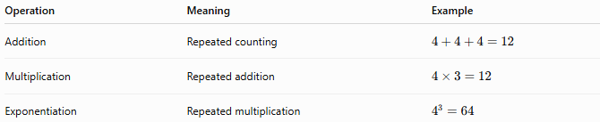
Operation | Meaning | Example
Addition | Repeated counting | $$4+4+4=12$$
Multiplication | Repeated addition | $$4×3=12$$
Exponentiation | Repeated multiplication | $$4^{3}=64$$

Real-Life Applications
# Source: AI Source: Provided by: [Data Path: Persons Table -> ID Column: 1, Name_En Column: Motasem Essam] -> From: [ChatGPT] on [7/11/2026]
Exponentiation of whole numbers is used in:
- Calculating areas and volumes
- Scientific notation
- Computer memory and data storage
- Population growth models
- Compound interest formulas
- Physics and engineering
- Binary numbers in computing
- Cryptography

Real-Life Examples
# Source: AI Source: Provided by: [Data Path: Persons Table -> ID Column: 1, Name_En Column: Motasem Essam] -> From: [ChatGPT] on [7/11/2026]
1. Area of a Square
A square has a side length of 8 m.
Area:
$$8^{2}=64$$
The area is 64 square meters.

2. Volume of a Cube
A cube has an edge length of 5 cm.
Volume:
$$5^{3}=125$$
The volume is 125 cubic centimeters.

3. Computer Storage
A computer uses 1024 bytes in one kilobyte.
Since
$$1024=2^{10}$$
powers of 2 are fundamental in digital storage.

4. Chessboard Doubling
A chessboard problem doubles the number of grains of rice on each square.
After 10 doublings:
$$2^{10}=1024$$
There are 1,024 grains on the 10th square.

5. Building Design
A square floor measures 12 m on each side.
Area:
$${12}^{2}=144$$
The floor area is 144 square meters.

6. Cube Stack
A storage container is 6 units long, 6 units wide, and 6 units high.
Volume:
$$6^{3}=216$$
The container holds 216 cubic units.

7. Binary Numbers
An 8-bit binary number can represent:
$$2^{8}=256$$
different values.

8. Large Numbers
One million can be written as:
$${10}^{6}=1, \text{⁣}000, \text{⁣}000$$
Exponentiation provides a compact way to express very large numbers.

Common Mistakes
# Source: AI Source: Provided by: [Data Path: Persons Table -> ID Column: 1, Name_En Column: Motasem Essam] -> From: [ChatGPT] on [7/11/2026]
- Confusing multiplication with exponentiation (e.g., $3^{2}≠3×2$).
- Multiplying the base by the exponent instead of repeatedly multiplying the base.
- Assuming $a^{m}+a^{n}=a^{m+n}$, which is incorrect.
- Forgetting that $a^{0}=1$for any nonzero $a$.
- Assuming $0^{0}=1$; in mathematics, $0^{0}$is generally undefined or indeterminate.

Key Points
# Source: AI Source: Provided by: [Data Path: Persons Table -> ID Column: 1, Name_En Column: Motasem Essam] -> From: [ChatGPT] on [7/11/2026]
- Exponentiation is repeated multiplication.
- The number being multiplied is the base.
- The number indicating how many times the base is multiplied is the exponent.
- The result is called the power.
- Any nonzero number raised to the zero power equals 1.
- Zero raised to a positive exponent equals 0.
- Exponentiation follows important laws such as the product, quotient, and power rules.

Whole Number Multiplication vs. Exponentiation
# Source: AI Source: Provided by: [Data Path: Persons Table -> ID Column: 1, Name_En Column: Motasem Essam] -> From: [ChatGPT] on [7/11/2026]
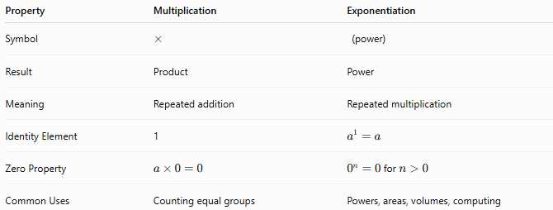
Property | Multiplication | Exponentiation
Symbol | $$×$$ | (power)
Result | Product | Power
Meaning | Repeated addition | Repeated multiplication
Identity Element | 1 | $$a^{1}=a$$
Zero Property | $$a×0=0$$ | $0^{n}=0$for $n>0$
Common Uses | Counting equal groups | Powers, areas, volumes, computing

Conclusion
# Source: AI Source: Provided by: [Data Path: Persons Table -> ID Column: 1, Name_En Column: Motasem Essam] -> From: [ChatGPT] on [7/11/2026]
Exponentiation (Power) is the arithmetic operation of repeatedly multiplying a whole number by itself. It provides a compact and efficient way to express repeated multiplication and is fundamental to mathematics, science, engineering, and computer science. Understanding bases, exponents, special cases, and the laws of exponents forms the foundation for algebra, geometry, and many advanced mathematical concepts.

Root (Radical)
# Source: AI Source: Provided by: [Data Path: Persons Table -> ID Column: 1, Name_En Column: Motasem Essam] -> From: [ChatGPT] on [7/11/2026]
Root extraction (commonly called finding a root) is the arithmetic operation of determining the number that, when raised to a given power, produces a specified whole number.
Root extraction is the inverse operation of exponentiation. The most common types are the square root and the cube root.

Definition
# Source: AI Source: Provided by: [Data Path: Persons Table -> ID Column: 1, Name_En Column: Motasem Essam] -> From: [ChatGPT] on [7/11/2026]
A root of a number is a value that, when raised to a specified exponent, equals the original number.
Mathematically:
For the $n$th root,
$$\sqrt[n]{a}=b$$
means
$$b^{n}=a$$
where:
- $a$is the radicand (the number under the radical).
- $n$is the index (the degree of the root).
- $b$is the root.
- xis the radical symbol.

Root Symbols
# Source: AI Source: Provided by: [Data Path: Persons Table -> ID Column: 1, Name_En Column: Motasem Essam] -> From: [ChatGPT] on [7/11/2026]
Common symbols include:
Square root:
$$\sqrt{a}$$
Cube root:
$$\sqrt[3]{a}$$
General $n$th root:
$$\sqrt[n]{a}$$
Examples:
$$\sqrt{49}=7 \\ \sqrt[3]{125}=5$$

Root as the Inverse of Exponentiation
# Source: AI Source: Provided by: [Data Path: Persons Table -> ID Column: 1, Name_En Column: Motasem Essam] -> From: [ChatGPT] on [7/11/2026]
Finding a root reverses exponentiation.
Example:
$$8^{2}=64$$
Therefore,
$$\sqrt{64}=8$$
Similarly,
$$4^{3}=64$$
Therefore,
$$\sqrt[3]{64}=4$$

Examples
# Source: AI Source: Provided by: [Data Path: Persons Table -> ID Column: 1, Name_En Column: Motasem Essam] -> From: [ChatGPT] on [7/11/2026]
Example 1
Find:
$$\sqrt{81}$$
Solution:
Since
$$9^{2}=81$$
then
$$\sqrt{81}=9$$

Example 2
Find:
$$\sqrt{144}$$
Solution:
Since
$${12}^{2}=144$$
then
$$\sqrt{144}=12$$

Example 3
Find:
$$\sqrt[3]{216}$$
Solution:
Since
$$6^{3}=216$$
then
$$\sqrt[3]{216}=6$$

Example 4
Find:
$$\sqrt[4]{81}$$
Solution:
Since
$$3^{4}=81$$
then
$$\sqrt[4]{81}=3$$

Perfect Squares
# Source: AI Source: Provided by: [Data Path: Persons Table -> ID Column: 1, Name_En Column: Motasem Essam] -> From: [ChatGPT] on [7/11/2026]
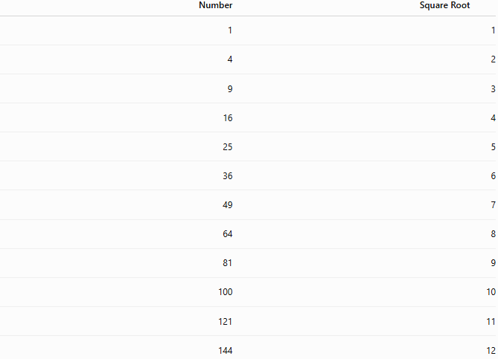
Number | Square Root
1 | 1
4 | 2
9 | 3
16 | 4
25 | 5
36 | 6
49 | 7
64 | 8
81 | 9
100 | 10
121 | 11
144 | 12

Perfect Cubes
# Source: AI Source: Provided by: [Data Path: Persons Table -> ID Column: 1, Name_En Column: Motasem Essam] -> From: [ChatGPT] on [7/11/2026]
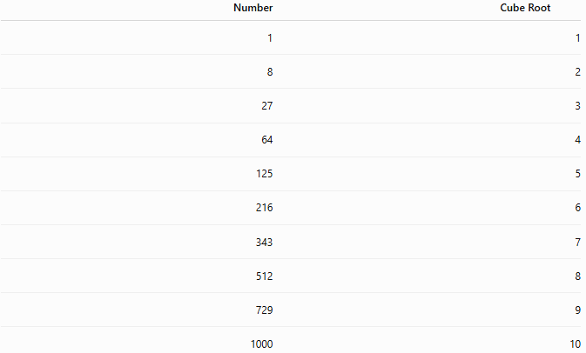
Number | Cube Root
1 | 1
8 | 2
27 | 3
64 | 4
125 | 5
216 | 6
343 | 7
512 | 8
729 | 9
1000 | 10

Properties of Roots

1. Inverse Property
# Source: AI Source: Provided by: [Data Path: Persons Table -> ID Column: 1, Name_En Column: Motasem Essam] -> From: [ChatGPT] on [7/11/2026]
Roots and exponents are inverse operations.
$$\sqrt[n]{a^{n}}=a$$
Example:
$$\sqrt{{11}^{2}}=11$$

2. Exponent Form
# Source: AI Source: Provided by: [Data Path: Persons Table -> ID Column: 1, Name_En Column: Motasem Essam] -> From: [ChatGPT] on [7/11/2026]
A root can be written as a fractional exponent.
$$\sqrt[n]{a}=a^{\frac{1}{n}}$$
Example:
$$\sqrt{49}={49}^{\frac{1}{2}}=7$$

3. Product Property
# Source: AI Source: Provided by: [Data Path: Persons Table -> ID Column: 1, Name_En Column: Motasem Essam] -> From: [ChatGPT] on [7/11/2026]
The root of a product equals the product of the roots.
$$\sqrt[n]{ab}=\sqrt[n]{a}×\sqrt[n]{b}$$
Example:
$$\sqrt{16×25}=4×5=20$$

4. Quotient Property
# Source: AI Source: Provided by: [Data Path: Persons Table -> ID Column: 1, Name_En Column: Motasem Essam] -> From: [ChatGPT] on [7/11/2026]
The root of a quotient equals the quotient of the roots.
$$\sqrt[n]{\frac{a}{b}}=\frac{\sqrt[n]{a}}{\sqrt[n]{b}}$$
where $b≠0$.
Example:
$$\sqrt{\frac{81}{9}}=\frac{9}{3}=3$$

Relationship Between Exponentiation and Roots
# Source: AI Source: Provided by: [Data Path: Persons Table -> ID Column: 1, Name_En Column: Motasem Essam] -> From: [ChatGPT] on [7/11/2026]
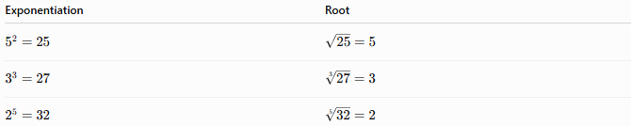
Exponentiation | Root
$$5^{2}=25$$ | $$\sqrt{25}=5$$
$$3^{3}=27$$ | $$\sqrt[3]{27}=3$$
$$2^{5}=32$$ | $$\sqrt[5]{32}=2$$

Real-Life Applications
# Source: AI Source: Provided by: [Data Path: Persons Table -> ID Column: 1, Name_En Column: Motasem Essam] -> From: [ChatGPT] on [7/11/2026]
Roots are used in:
- Geometry
- Construction
- Engineering
- Physics
- Statistics
- Computer graphics
- Navigation
- Scientific calculations

Real-Life Examples
# Source: AI Source: Provided by: [Data Path: Persons Table -> ID Column: 1, Name_En Column: Motasem Essam] -> From: [ChatGPT] on [7/11/2026]
1. Finding the Side of a Square
A square has an area of 196 m².
Side length:
$$\sqrt{196}=14$$
The side of the square is 14 meters.

2. Cube Storage Box
A cube has a volume of 343 cm³.
Edge length:
$$\sqrt[3]{343}=7$$
The edge of the cube is 7 centimeters.

3. Garden Design
A square garden has an area of 400 m².
Side length:
$$\sqrt{400}=20$$
Each side is 20 meters.

4. Construction
A square floor covers 625 m².
Length of one side:
$$\sqrt{625}=25$$
The floor measures 25 meters on each side.

5. Packaging
A cube-shaped box has a volume of 729 cm³.
Edge length:
$$\sqrt[3]{729}=9$$
Each edge measures 9 centimeters.

6. Land Measurement
A square piece of land has an area of 900 m².
Length of one side:
$$\sqrt{900}=30$$
Each side is 30 meters.

7. Mathematics
Find the number whose square is 169.
$$\sqrt{169}=13$$
The number is 13.

8. Engineering
A cube-shaped water tank has a volume of 1,000 m³.
Length of one edge:
$$\sqrt[3]{1000}=10$$
The tank has edges of 10 meters.

Common Mistakes
# Source: AI Source: Provided by: [Data Path: Persons Table -> ID Column: 1, Name_En Column: Motasem Essam] -> From: [ChatGPT] on [7/11/2026]
- Confusing roots with exponents.
- Assuming every whole number has a whole-number square root.
- Forgetting that only perfect squares have whole-number square roots.
- Ignoring the index of the radical (square root vs. cube root).
- Confusing $\sqrt{a+b}$with $\sqrt{a}+\sqrt{b}$, which is generally incorrect.

Key Points
# Source: AI Source: Provided by: [Data Path: Persons Table -> ID Column: 1, Name_En Column: Motasem Essam] -> From: [ChatGPT] on [7/11/2026]
- Root extraction is the inverse of exponentiation.
- The number under the radical is the radicand.
- The result is called the root.
- Square roots use the symbol x.
- Cube roots use the symbol 3x.
- Perfect squares have whole-number square roots.
- Perfect cubes have whole-number cube roots.
- Not every whole number has a whole-number root.

Whole Number Exponentiation vs. Root
# Source: AI Source: Provided by: [Data Path: Persons Table -> ID Column: 1, Name_En Column: Motasem Essam] -> From: [ChatGPT] on [7/11/2026]
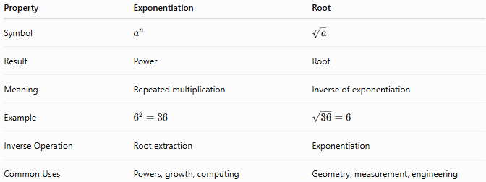
Property | Exponentiation | Root
Symbol | $$a^{n}$$ | $$\sqrt[n]{a}$$
Result | Power | Root
Meaning | Repeated multiplication | Inverse of exponentiation
Example | $$6^{2}=36$$ | $$\sqrt{36}=6$$
Inverse Operation | Root extraction | Exponentiation
Common Uses | Powers, growth, computing | Geometry, measurement, engineering

Conclusion
# Source: AI Source: Provided by: [Data Path: Persons Table -> ID Column: 1, Name_En Column: Motasem Essam] -> From: [ChatGPT] on [7/11/2026]
Root extraction is the arithmetic operation of finding the number that produces a given value when raised to a specified power. It is the inverse of exponentiation and includes operations such as square roots and cube roots. Roots are essential in mathematics and have many practical applications in geometry, engineering, science, construction, and technology. Understanding roots provides a foundation for algebra, geometry, and higher-level mathematics.

Logarithm
# Source: AI Source: Provided by: [Data Path: Persons Table -> ID Column: 1, Name_En Column: Motasem Essam] -> From: [ChatGPT] on [7/11/2026]
Logarithm is the arithmetic operation that determines the exponent to which a base must be raised to obtain a given number. It is the inverse operation of exponentiation.
Logarithms provide a compact way to solve exponential equations and are widely used in mathematics, science, engineering, finance, computer science, and information theory.

Definition
# Source: AI Source: Provided by: [Data Path: Persons Table -> ID Column: 1, Name_En Column: Motasem Essam] -> From: [ChatGPT] on [7/11/2026]
Definition:
A logarithm answers the question:
"To what power must the base be raised to obtain a given number?"
Mathematically:
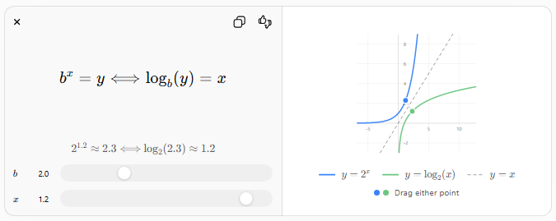
$$b^{x}=y⟺{log⁡}_{b}(y)=x$$
$$2^{1.2}≈2.3⟺{log⁡}_{2} \text{⁣}\left(2.3\right)≈1.2$$
$$b$$
$$b$$
$$x$$
$$x$$
-5510-22468
$$y=2^{x}$$
$$y={log⁡}_{2}(x)$$
$$y=x$$
Drag either point
$${log⁡}_{b}(a)=x$$
means
$$b^{x}=a$$
where:
- $b$is the base ($b>0, b≠1$)
- $a$is the argument (or logarithmic number) ($a>0$)
- $x$is the logarithm (the exponent)

Logarithm Symbols
# Source: AI Source: Provided by: [Data Path: Persons Table -> ID Column: 1, Name_En Column: Motasem Essam] -> From: [ChatGPT] on [7/11/2026]
The logarithm is written as:
$${log⁡}_{b}(a)$$
Common logarithms include:
- Common logarithm (base 10):
$$log⁡(a)$$
- Natural logarithm (base $e$):
$$ln⁡(a)$$
Example:
$${log⁡}_{2}(8)=3$$
because
$$2^{3}=8$$

Logarithm as the Inverse of Exponentiation
# Source: AI Source: Provided by: [Data Path: Persons Table -> ID Column: 1, Name_En Column: Motasem Essam] -> From: [ChatGPT] on [7/11/2026]
Logarithms reverse exponentiation.
Example:
$$5^{4}=625$$
Therefore,
$${log⁡}_{5}(625)=4$$
Similarly,
$${10}^{3}=1000$$
Therefore,
$${log⁡}_{10}(1000)=3$$

Examples
# Source: AI Source: Provided by: [Data Path: Persons Table -> ID Column: 1, Name_En Column: Motasem Essam] -> From: [ChatGPT] on [7/11/2026]
Example 1
Find:
$${log⁡}_{2}(16)$$
Solution:
Since
$$2^{4}=16$$
then
$${log⁡}_{2}(16)=4$$

Example 2
Find:
$${log⁡}_{5}(125)$$
Solution:
Since
$$5^{3}=125$$
then
$${log⁡}_{5}(125)=3$$

Example 3
Find:
$${log⁡}_{10}(1000)$$
Solution:
Since
$${10}^{3}=1000$$
then
$${log⁡}_{10}(1000)=3$$

Example 4
Find:
$${log⁡}_{3}(81)$$
Solution:
Since
$$3^{4}=81$$
then
$${log⁡}_{3}(81)=4$$

Common Logarithms
# Source: AI Source: Provided by: [Data Path: Persons Table -> ID Column: 1, Name_En Column: Motasem Essam] -> From: [ChatGPT] on [7/11/2026]
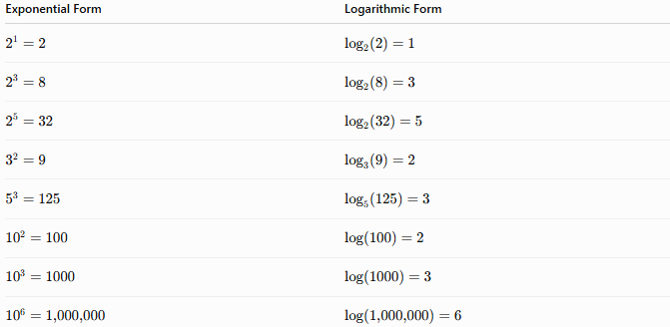
Exponential Form | Logarithmic Form
$$2^{1}=2$$ | $${log⁡}_{2}(2)=1$$
$$2^{3}=8$$ | $${log⁡}_{2}(8)=3$$
$$2^{5}=32$$ | $${log⁡}_{2}(32)=5$$
$$3^{2}=9$$ | $${log⁡}_{3}(9)=2$$
$$5^{3}=125$$ | $${log⁡}_{5}(125)=3$$
$${10}^{2}=100$$ | $$log⁡(100)=2$$
$${10}^{3}=1000$$ | $$log⁡(1000)=3$$
$${10}^{6}=1, \text{⁣}000, \text{⁣}000$$ | $$log⁡(1, \text{⁣}000, \text{⁣}000)=6$$

Special Cases

1. Logarithm of One
# Source: AI Source: Provided by: [Data Path: Persons Table -> ID Column: 1, Name_En Column: Motasem Essam] -> From: [ChatGPT] on [7/11/2026]
For every valid base,
$${log⁡}_{b}(1)=0$$
because
$$b^{0}=1$$
Example:
$${log⁡}_{7}(1)=0$$

2. Logarithm of the Base
# Source: AI Source: Provided by: [Data Path: Persons Table -> ID Column: 1, Name_En Column: Motasem Essam] -> From: [ChatGPT] on [7/11/2026]
$${log⁡}_{b}(b)=1$$
because
$$b^{1}=b$$
Example:
$${log⁡}_{9}(9)=1$$

3. Logarithm of a Power
# Source: AI Source: Provided by: [Data Path: Persons Table -> ID Column: 1, Name_En Column: Motasem Essam] -> From: [ChatGPT] on [7/11/2026]
$${log⁡}_{b}(b^{n})=n$$
Example:
$${log⁡}_{4}(64)=3$$
because
$$4^{3}=64$$

Properties of Logarithms
# Source: AI Source: Provided by: [Data Path: Persons Table -> ID Column: 1, Name_En Column: Motasem Essam] -> From: [ChatGPT] on [7/11/2026]
Let $a>0$, $b>0$, $b≠1$, and $x,y>0$.

1. Product Rule
# Source: AI Source: Provided by: [Data Path: Persons Table -> ID Column: 1, Name_En Column: Motasem Essam] -> From: [ChatGPT] on [7/11/2026]
$${log⁡}_{b}(xy)={log⁡}_{b}(x)+{log⁡}_{b}(y)$$
Example:
$${log⁡}_{10}(1000)={log⁡}_{10}(100)+{log⁡}_{10}(10)=2+1=3$$

2. Quotient Rule
# Source: AI Source: Provided by: [Data Path: Persons Table -> ID Column: 1, Name_En Column: Motasem Essam] -> From: [ChatGPT] on [7/11/2026]
$${log⁡}_{b}\left(\frac{x}{y}\right)={log⁡}_{b}(x)-{log⁡}_{b}(y)$$
Example:
$${log⁡}_{10}(100)-{log⁡}_{10}(10)=2-1=1$$

3. Power Rule
# Source: AI Source: Provided by: [Data Path: Persons Table -> ID Column: 1, Name_En Column: Motasem Essam] -> From: [ChatGPT] on [7/11/2026]
$${log⁡}_{b}(x^{n})=n{log⁡}_{b}(x)$$
Example:
$${log⁡}_{2}(8^{2})=2{log⁡}_{2}(8)=2×3=6$$

4. Inverse Property
# Source: AI Source: Provided by: [Data Path: Persons Table -> ID Column: 1, Name_En Column: Motasem Essam] -> From: [ChatGPT] on [7/11/2026]
Exponentials and logarithms undo each other.
$${log⁡}_{b}(b^{x})=x$$
and
$$b^{{log⁡}_{b}(x)}=x$$

5. Change of Base Formula
# Source: AI Source: Provided by: [Data Path: Persons Table -> ID Column: 1, Name_En Column: Motasem Essam] -> From: [ChatGPT] on [7/11/2026]
A logarithm with one base can be converted to another base.
$${log⁡}_{b}(a)=\frac{log⁡(a)}{log⁡(b)}$$
Example:
$${log⁡}_{2}(16)=\frac{log⁡(16)}{log⁡(2)}=4$$

Relationship Between Exponentiation and Logarithms
# Source: AI Source: Provided by: [Data Path: Persons Table -> ID Column: 1, Name_En Column: Motasem Essam] -> From: [ChatGPT] on [7/11/2026]
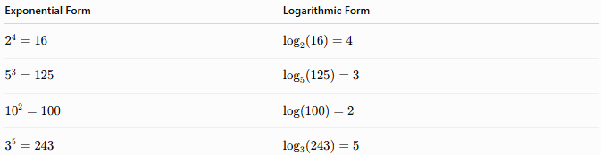
Exponential Form | Logarithmic Form
$$2^{4}=16$$ | $${log⁡}_{2}(16)=4$$
$$5^{3}=125$$ | $${log⁡}_{5}(125)=3$$
$${10}^{2}=100$$ | $$log⁡(100)=2$$
$$3^{5}=243$$ | $${log⁡}_{3}(243)=5$$

Real-Life Applications
# Source: AI Source: Provided by: [Data Path: Persons Table -> ID Column: 1, Name_En Column: Motasem Essam] -> From: [ChatGPT] on [7/11/2026]
Logarithms are used in:
- Solving exponential equations
- Measuring earthquake magnitudes (Richter scale)
- Measuring sound intensity (decibels)
- Compound interest calculations
- Population growth analysis
- Computer science and algorithms
- Information theory
- Scientific calculations

Real-Life Examples
# Source: AI Source: Provided by: [Data Path: Persons Table -> ID Column: 1, Name_En Column: Motasem Essam] -> From: [ChatGPT] on [7/11/2026]
1. Earthquake Magnitude
The Richter scale uses logarithms to measure earthquake strength.
An increase of 1 on the scale represents about 10 times greater wave amplitude.

2. Sound Measurement
Sound intensity is measured in decibels (dB) using logarithms.
A sound of 20 dB is much more intense than 10 dB.

3. Computer Science
Algorithms such as binary search require approximately
$${log⁡}_{2}(n)$$
comparisons.
For 1024 items:
$${log⁡}_{2}(1024)=10$$
Only 10 comparisons are needed in the ideal case.

4. Population Growth
Scientists use logarithms to estimate the time required for populations to reach certain sizes under exponential growth.

5. Finance
Logarithms help determine how long it takes for an investment to reach a target value under compound interest.

6. Information Storage
The number of bits needed to represent values is determined using logarithms.
For 256 values:
$${log⁡}_{2}(256)=8$$
Eight bits are required.

7. Chemistry
The pH scale is logarithmic.
For example, a solution with
$$\text{pH}=3$$
is much more acidic than one with
$$\text{pH}=4$$

8. Astronomy
Astronomers use logarithmic scales to compare the brightness of stars over extremely large ranges.

Common Mistakes
# Source: AI Source: Provided by: [Data Path: Persons Table -> ID Column: 1, Name_En Column: Motasem Essam] -> From: [ChatGPT] on [7/11/2026]
- Confusing logarithms with exponents.
- Forgetting that the argument of a logarithm must be positive.
- Using a base of 1 or 0, which is not allowed.
- Assuming
$$log⁡(x+y)=log⁡(x)+log⁡(y)$$
which is incorrect.
- Mixing logarithm bases without using the change of base formula.

Key Points
# Source: AI Source: Provided by: [Data Path: Persons Table -> ID Column: 1, Name_En Column: Motasem Essam] -> From: [ChatGPT] on [7/11/2026]
- A logarithm finds the exponent needed to produce a given number.
- Logarithms are the inverse of exponentiation.
- The most common bases are 10, 2, and $e$.
- ${log⁡}_{b}(1)=0$.
- ${log⁡}_{b}(b)=1$.
- Logarithms obey the product, quotient, power, and change of base rules.
- Logarithms are essential in mathematics, science, engineering, and computing.

Whole Number Exponentiation vs. Logarithm
# Source: AI Source: Provided by: [Data Path: Persons Table -> ID Column: 1, Name_En Column: Motasem Essam] -> From: [ChatGPT] on [7/11/2026]
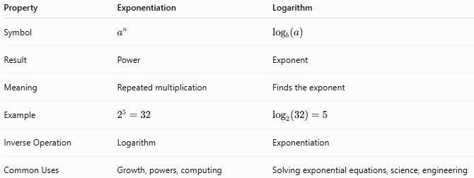
Property | Exponentiation | Logarithm
Symbol | $$a^{n}$$ | $${log⁡}_{b}(a)$$
Result | Power | Exponent
Meaning | Repeated multiplication | Finds the exponent
Example | $$2^{5}=32$$ | $${log⁡}_{2}(32)=5$$
Inverse Operation | Logarithm | Exponentiation
Common Uses | Growth, powers, computing | Solving exponential equations, science, engineering

Conclusion
# Source: AI Source: Provided by: [Data Path: Persons Table -> ID Column: 1, Name_En Column: Motasem Essam] -> From: [ChatGPT] on [7/11/2026]
Logarithms are the arithmetic operation used to determine the exponent required to produce a given number from a specified base. They are the inverse of exponentiation and play a fundamental role in mathematics, science, engineering, finance, and computer science. Understanding logarithms and their properties provides the foundation for solving exponential equations, analyzing growth and decay, and working with many real-world measurement scales.

Natural Logarithm
# Source: AI Source: Provided by: [Data Path: Persons Table -> ID Column: 1, Name_En Column: Motasem Essam] -> From: [ChatGPT] on [7/11/2026]
The natural logarithm is a special type of logarithm that uses the mathematical constant $e$(Euler's number) as its base.
The natural logarithm is the inverse operation of the natural exponential function $e^{x}$. It is one of the most important functions in mathematics, calculus, science, engineering, finance, probability, and computer science.
Note: Although this topic is commonly introduced after logarithms, it is not strictly a whole number arithmetic operation because the base $e$is an irrational number ($e≈2.718281828$). However, it is included here because it is a fundamental extension of logarithms.

Definition
# Source: AI Source: Provided by: [Data Path: Persons Table -> ID Column: 1, Name_En Column: Motasem Essam] -> From: [ChatGPT] on [7/11/2026]
The natural logarithm is the logarithm with base $e$.
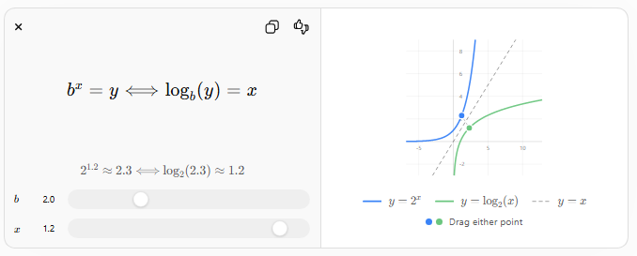
$$b^{x}=y⟺{log⁡}_{b}(y)=x$$
$$2^{1.2}≈2.3⟺{log⁡}_{2} \text{⁣}\left(2.3\right)≈1.2$$
$$b$$
$$b$$
$$x$$
$$x$$
-5510-22468
$$y=2^{x}$$
$$y={log⁡}_{2}(x)$$
$$y=x$$
Drag either point

Mathematically,
$$ln⁡(x)={log⁡}_{e}(x)$$
which means
$$ln⁡(x)=y$$
if and only if
$$e^{y}=x$$
where:
- $e≈2.718281828$is Euler's number
- $x>0$is the argument
- $y$is the natural logarithm

Natural Logarithm Symbol
# Source: AI Source: Provided by: [Data Path: Persons Table -> ID Column: 1, Name_En Column: Motasem Essam] -> From: [ChatGPT] on [7/11/2026]
The natural logarithm is written as:
$$\boxed{ln⁡(x)}$$
Examples:
$$ln⁡(e)=1 \\ ln⁡(1)=0$$

Natural Logarithm as the Inverse of the Exponential Function
# Source: AI Source: Provided by: [Data Path: Persons Table -> ID Column: 1, Name_En Column: Motasem Essam] -> From: [ChatGPT] on [7/11/2026]
The natural logarithm reverses exponentiation with base $e$.
Example:
$$e^{3}≈20.0855$$
Therefore,
$$ln⁡(20.0855)=3$$
Similarly,
$$e^{5}≈148.413$$
Therefore,
$$ln⁡(148.413)=5$$

Examples
# Source: AI Source: Provided by: [Data Path: Persons Table -> ID Column: 1, Name_En Column: Motasem Essam] -> From: [ChatGPT] on [7/11/2026]
Example 1
Find:
$$ln⁡(e)$$
Solution:
Since
$$e^{1}=e$$
then
$$ln⁡(e)=1$$

Example 2
Find:
$$ln⁡(1)$$
Solution:
Since
$$e^{0}=1$$
then
$$ln⁡(1)=0$$

Example 3
Find:
$$ln⁡(e^{4})$$
Solution:
$$ln⁡(e^{4})=4$$

Example 4
Evaluate approximately:
$$ln⁡(10)$$
Solution:
$$ln⁡(10)≈2.3026$$

Important Values
# Source: AI Source: Provided by: [Data Path: Persons Table -> ID Column: 1, Name_En Column: Motasem Essam] -> From: [ChatGPT] on [7/11/2026]
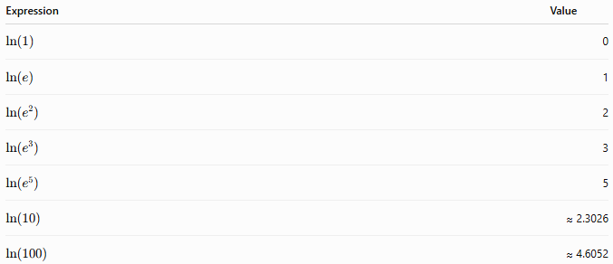
Expression | Value
$$ln⁡(1)$$ | 0
$$ln⁡(e)$$ | 1
$$ln⁡(e^{2})$$ | 2
$$ln⁡(e^{3})$$ | 3
$$ln⁡(e^{5})$$ | 5
$$ln⁡(10)$$ | ≈ 2.3026
$$ln⁡(100)$$ | ≈ 4.6052

Special Cases

1. Natural Logarithm of One
# Source: AI Source: Provided by: [Data Path: Persons Table -> ID Column: 1, Name_En Column: Motasem Essam] -> From: [ChatGPT] on [7/11/2026]
$$ln⁡(1)=0$$
because
$$e^{0}=1$$

2. Natural Logarithm of $e$
# Source: AI Source: Provided by: [Data Path: Persons Table -> ID Column: 1, Name_En Column: Motasem Essam] -> From: [ChatGPT] on [7/11/2026]
$$ln⁡(e)=1$$
because
$$e^{1}=e$$

3. Inverse Property
# Source: AI Source: Provided by: [Data Path: Persons Table -> ID Column: 1, Name_En Column: Motasem Essam] -> From: [ChatGPT] on [7/11/2026]
$$ln⁡(e^{x})=x$$
Example:
$$ln⁡(e^{8})=8$$

4. Exponential Inverse Property
# Source: AI Source: Provided by: [Data Path: Persons Table -> ID Column: 1, Name_En Column: Motasem Essam] -> From: [ChatGPT] on [7/11/2026]
$$e^{ln⁡(x)}=x$$
Example:
$$e^{ln⁡(12)}=12$$

5. Domain
# Source: AI Source: Provided by: [Data Path: Persons Table -> ID Column: 1, Name_En Column: Motasem Essam] -> From: [ChatGPT] on [7/11/2026]
The natural logarithm is defined only for positive numbers.
$$x>0$$
Examples:
Valid:
$$ln⁡(5)$$
Invalid:
$$ln⁡(0) \\ ln⁡(-4)$$

Properties of Natural Logarithms
Let $x>0$and $y>0$.

1. Product Rule
# Source: AI Source: Provided by: [Data Path: Persons Table -> ID Column: 1, Name_En Column: Motasem Essam] -> From: [ChatGPT] on [7/11/2026]
$$ln⁡(xy)=ln⁡(x)+ln⁡(y)$$
Example:
$$ln⁡(e^{2}⋅e^{3})=2+3=5$$

2. Quotient Rule
# Source: AI Source: Provided by: [Data Path: Persons Table -> ID Column: 1, Name_En Column: Motasem Essam] -> From: [ChatGPT] on [7/11/2026]
$$ln⁡\left(\frac{x}{y}\right)=ln⁡(x)-ln⁡(y)$$
Example:
$$ln⁡\left(\frac{e^{5}}{e^{2}}\right)=5-2=3$$

3. Power Rule
# Source: AI Source: Provided by: [Data Path: Persons Table -> ID Column: 1, Name_En Column: Motasem Essam] -> From: [ChatGPT] on [7/11/2026]
$$ln⁡(x^{n})=nln⁡(x)$$
Example:
$$ln⁡(e^{6})=6$$

4. Change of Base
# Source: AI Source: Provided by: [Data Path: Persons Table -> ID Column: 1, Name_En Column: Motasem Essam] -> From: [ChatGPT] on [7/11/2026]
The natural logarithm can be used to compute logarithms of any base.
$${log⁡}_{b}(x)=\frac{ln⁡(x)}{ln⁡(b)}$$
Example:
$${log⁡}_{2}(8)=\frac{ln⁡(8)}{ln⁡(2)}=3$$

Relationship Between Exponential and Natural Logarithm
# Source: AI Source: Provided by: [Data Path: Persons Table -> ID Column: 1, Name_En Column: Motasem Essam] -> From: [ChatGPT] on [7/11/2026]
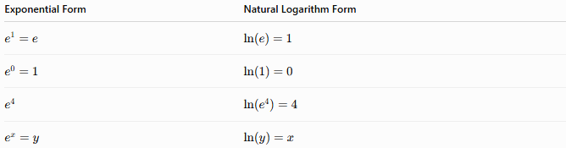
Exponential Form | Natural Logarithm Form
$$e^{1}=e$$ | $$ln⁡(e)=1$$
$$e^{0}=1$$ | $$ln⁡(1)=0$$
$$e^{4}$$ | $$ln⁡(e^{4})=4$$
$$e^{x}=y$$ | $$ln⁡(y)=x$$

Real-Life Applications
# Source: AI Source: Provided by: [Data Path: Persons Table -> ID Column: 1, Name_En Column: Motasem Essam] -> From: [ChatGPT] on [7/11/2026]
The natural logarithm is used in:
- Calculus
- Differential equations
- Compound interest
- Population growth
- Radioactive decay
- Probability and statistics
- Machine learning
- Physics and engineering

Real-Life Examples
# Source: AI Source: Provided by: [Data Path: Persons Table -> ID Column: 1, Name_En Column: Motasem Essam] -> From: [ChatGPT] on [7/11/2026]
1. Compound Interest
Banks use natural logarithms to determine how long an investment takes to reach a desired value under continuous compounding.

2. Population Growth
Scientists model continuously growing populations using exponential functions and natural logarithms.

3. Radioactive Decay
The age of radioactive materials is determined using natural logarithms.

4. Cooling and Heating
Engineers use natural logarithms when applying Newton's Law of Cooling.

5. Biology
Natural logarithms describe bacterial growth and enzyme reactions.

6. Machine Learning
Many optimization algorithms use the natural logarithm in log-loss and probability calculations.

7. Information Theory
Natural logarithms are used to calculate entropy and information content.

8. Finance
Economists use natural logarithms to compute continuously compounded rates of return.

Common Mistakes
# Source: AI Source: Provided by: [Data Path: Persons Table -> ID Column: 1, Name_En Column: Motasem Essam] -> From: [ChatGPT] on [7/11/2026]
- Confusing $ln⁡(x)$with $log⁡(x)$.
- Forgetting that the base of $ln⁡$is always $e$.
- Trying to evaluate the natural logarithm of zero or a negative number.
- Assuming
$$ln⁡(x+y)=ln⁡(x)+ln⁡(y)$$
which is incorrect.
- Forgetting that
$$ln⁡(e^{x})=x$$

Key Points
# Source: AI Source: Provided by: [Data Path: Persons Table -> ID Column: 1, Name_En Column: Motasem Essam] -> From: [ChatGPT] on [7/11/2026]
- The natural logarithm is the logarithm with base $e$.
- It is written as $ln⁡(x)$.
- It is the inverse of the exponential function $e^{x}$.
- $ln⁡(1)=0$.
- $ln⁡(e)=1$.
- It is defined only for positive numbers.
- Natural logarithms satisfy the product, quotient, and power rules.
- They are fundamental in calculus, science, finance, and engineering.

Logarithm vs. Natural Logarithm
# Source: AI Source: Provided by: [Data Path: Persons Table -> ID Column: 1, Name_En Column: Motasem Essam] -> From: [ChatGPT] on [7/11/2026]
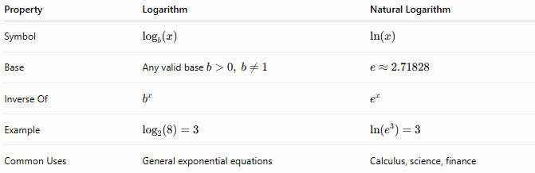
Property | Logarithm | Natural Logarithm
Symbol | $${log⁡}_{b}(x)$$ | $$ln⁡(x)$$
Base | Any valid base $b>0, b≠1$ | $$e≈2.71828$$
Inverse Of | $$b^{x}$$ | $$e^{x}$$
Example | $${log⁡}_{2}(8)=3$$ | $$ln⁡(e^{3})=3$$
Common Uses | General exponential equations | Calculus, science, finance

Conclusion
# Source: AI Source: Provided by: [Data Path: Persons Table -> ID Column: 1, Name_En Column: Motasem Essam] -> From: [ChatGPT] on [7/11/2026]
The natural logarithm is the logarithm with base $e$and is written as $ln⁡(x)$. It is the inverse of the natural exponential function and is one of the most important mathematical functions in higher mathematics. Although it is not strictly a whole number arithmetic operation because its base is the irrational number $e$, it is a fundamental extension of logarithms and is indispensable in calculus, science, engineering, economics, and computer science.

Simplifying Radicals
# Source: AI Source: Provided by: [Data Path: Persons Table -> ID Column: 1, Name_En Column: Motasem Essam] -> From: [ChatGPT] on [7/11/2026]
Simplifying Radicals is the process of rewriting a radical expression in its simplest equivalent form by removing perfect powers from the radicand whenever possible.
Simplifying radicals makes expressions easier to read, compare, and use in arithmetic, algebra, geometry, trigonometry, calculus, engineering, and science.

Definition
# Source: AI Source: Provided by: [Data Path: Persons Table -> ID Column: 1, Name_En Column: Motasem Essam] -> From: [ChatGPT] on [7/11/2026]
A radical is an expression involving a root.
A radical has the form
$$\sqrt[n]{a}$$
where
- $n$is the index (degree of the root),
- $a$is the radicand (number inside the radical).
A radical is simplified when
- the radicand contains no perfect $n$-th power factors,
- no radicals appear in the denominator (when applicable),
- the expression cannot be simplified further.

Principle of Simplifying Radicals
# Source: AI Source: Provided by: [Data Path: Persons Table -> ID Column: 1, Name_En Column: Motasem Essam] -> From: [ChatGPT] on [7/11/2026]
If the radicand contains a perfect power, it can be factored out.
$$\sqrt[n]{a^{n}b}=a\sqrt[n]{b}$$

Example
$$\sqrt{36}=6$$
because
$$36=6^{2}.$$

Example
$$\sqrt[3]{125}=5$$
because
$$125=5^{3}.$$

Simplifying Square Roots
# Source: AI Source: Provided by: [Data Path: Persons Table -> ID Column: 1, Name_En Column: Motasem Essam] -> From: [ChatGPT] on [7/11/2026]
Factor the radicand into a perfect square and the remaining factor.
Example
$$\sqrt{12}=\sqrt{4×3}=2\sqrt{3}$$

Example
$$\sqrt{18}=\sqrt{9×2}=3\sqrt{2}$$

Example
$$\sqrt{72}=\sqrt{36×2}=6\sqrt{2}$$

Example
$$\sqrt{200}=\sqrt{100×2}=10\sqrt{2}$$

Simplifying Cube Roots
# Source: AI Source: Provided by: [Data Path: Persons Table -> ID Column: 1, Name_En Column: Motasem Essam] -> From: [ChatGPT] on [7/11/2026]
Extract perfect cubes.
Example
$$\sqrt[3]{16}=\sqrt[3]{8×2}=2\sqrt[3]{2}$$

Example
$$\sqrt[3]{54}=\sqrt[3]{27×2}=3\sqrt[3]{2}$$

Example
$$\sqrt[3]{250}=\sqrt[3]{125×2}=5\sqrt[3]{2}$$

Simplifying Higher-Order Roots
# Source: AI Source: Provided by: [Data Path: Persons Table -> ID Column: 1, Name_En Column: Motasem Essam] -> From: [ChatGPT] on [7/11/2026]
Example
$$\sqrt[4]{48}=\sqrt[4]{16×3}=2\sqrt[4]{3}$$

Example
$$\sqrt[5]{96}=\sqrt[5]{32×3}=2\sqrt[5]{3}$$

Simplifying Radicals with Variables
# Source: AI Source: Provided by: [Data Path: Persons Table -> ID Column: 1, Name_En Column: Motasem Essam] -> From: [ChatGPT] on [7/11/2026]
Variables are simplified in the same way.
Example
$$\sqrt{x^{2}}=∣x∣$$
For
$$x≥0,$$
this becomes
$$\sqrt{x^{2}}=x.$$

Example
$$\sqrt{50x^{2}}=5x\sqrt{2}$$
(for $x≥0$)

Example
$$\sqrt[3]{54x^{6}}=3x^{2}\sqrt[3]{2}$$

Product Property
# Source: AI Source: Provided by: [Data Path: Persons Table -> ID Column: 1, Name_En Column: Motasem Essam] -> From: [ChatGPT] on [7/11/2026]
$$\sqrt[n]{ab}=\sqrt[n]{a}\sqrt[n]{b}$$
Example
$$\sqrt{45}=\sqrt{9}\sqrt{5}=3\sqrt{5}$$

Quotient Property
# Source: AI Source: Provided by: [Data Path: Persons Table -> ID Column: 1, Name_En Column: Motasem Essam] -> From: [ChatGPT] on [7/11/2026]
$$\sqrt[n]{\frac{a}{b}}=\frac{\sqrt[n]{a}}{\sqrt[n]{b}}$$
provided
$$b>0.$$
Example
$$\sqrt{\frac{36}{25}}=\frac{6}{5}$$

Perfect Powers
# Source: AI Source: Provided by: [Data Path: Persons Table -> ID Column: 1, Name_En Column: Motasem Essam] -> From: [ChatGPT] on [7/11/2026]
Perfect Squares
$$1, 4, 9, 16, 25, 36, 49, 64, 81, 100,…$$

Perfect Cubes
$$1, 8, 27, 64, 125, 216,…$$

Perfect Fourth Powers
$$1, 16, 81, 256, 625,…$$

Prime Factorization Method
# Source: AI Source: Provided by: [Data Path: Persons Table -> ID Column: 1, Name_En Column: Motasem Essam] -> From: [ChatGPT] on [7/11/2026]
Factor the radicand into prime factors.
Group identical factors according to the index.
Example
Simplify
$$\sqrt{72}$$
Prime factorization:
$$72=2^{3}⋅3^{2}$$
Take one pair of twos and one pair of threes outside:
$$\sqrt{72}=2⋅3\sqrt{2}=6\sqrt{2}$$

Example
Simplify
$$\sqrt[3]{432}$$
Prime factorization:
$$432=2^{4}⋅3^{3}$$
Take one group of three twos and one group of three threes:
$$\sqrt[3]{432}=6\sqrt[3]{2}$$

Operations with Simplified Radicals

Addition
# Source: AI Source: Provided by: [Data Path: Persons Table -> ID Column: 1, Name_En Column: Motasem Essam] -> From: [ChatGPT] on [7/11/2026]
Only like radicals may be combined.

Example
$$2\sqrt{5}+3\sqrt{5}=5\sqrt{5}$$

Example
$$\sqrt{2}+\sqrt{3}$$
cannot be simplified further.

Subtraction
# Source: AI Source: Provided by: [Data Path: Persons Table -> ID Column: 1, Name_En Column: Motasem Essam] -> From: [ChatGPT] on [7/11/2026]

Example
$$7\sqrt{3}-2\sqrt{3}=5\sqrt{3}$$

Multiplication
# Source: AI Source: Provided by: [Data Path: Persons Table -> ID Column: 1, Name_En Column: Motasem Essam] -> From: [ChatGPT] on [7/11/2026]
Multiply coefficients and radicands.

Example
$$(2\sqrt{3})(5\sqrt{2})=10\sqrt{6}$$

Example
$$\left(\sqrt{5})^{2} = 5\right.$$

Division
# Source: AI Source: Provided by: [Data Path: Persons Table -> ID Column: 1, Name_En Column: Motasem Essam] -> From: [ChatGPT] on [7/11/2026]
Example
$$\frac{12\sqrt{5}}{4}=3\sqrt{5}$$

Rationalizing the Denominator
# Source: AI Source: Provided by: [Data Path: Persons Table -> ID Column: 1, Name_En Column: Motasem Essam] -> From: [ChatGPT] on [7/11/2026]
If a radical appears in the denominator, multiply by a suitable radical.
Example
$$\frac{1}{\sqrt{2}}=\frac{\sqrt{2}}{2}$$

Example
$$\frac{3}{\sqrt{5}}=\frac{3\sqrt{5}}{5}$$

Examples
# Source: AI Source: Provided by: [Data Path: Persons Table -> ID Column: 1, Name_En Column: Motasem Essam] -> From: [ChatGPT] on [7/11/2026]
Example 1
$$\sqrt{48}=4\sqrt{3}$$

Example 2
$$\sqrt{75}=5\sqrt{3}$$

Example 3
$$\sqrt[3]{108}=3\sqrt[3]{4}$$

Example 4
$$\sqrt{98}=7\sqrt{2}$$

Example 5
$$\sqrt[4]{162}=3\sqrt[4]{2}$$

Example 6
$$\sqrt{180}=6\sqrt{5}$$

Applications
# Source: AI Source: Provided by: [Data Path: Persons Table -> ID Column: 1, Name_En Column: Motasem Essam] -> From: [ChatGPT] on [7/11/2026]
Simplifying radicals is used in:
- Arithmetic
- Algebra
- Geometry
- Trigonometry
- Calculus
- Engineering
- Physics
- Computer Science
- Statistics
- Scientific Computing

Real-Life Applications
# Source: AI Source: Provided by: [Data Path: Persons Table -> ID Column: 1, Name_En Column: Motasem Essam] -> From: [ChatGPT] on [7/11/2026]
Simplifying radicals is used in:
- Distance calculations
- Geometry
- Structural engineering
- Electrical engineering
- Physics
- Computer graphics
- Navigation
- Architecture
- Robotics
- Scientific measurements

Real-Life Examples
# Source: AI Source: Provided by: [Data Path: Persons Table -> ID Column: 1, Name_En Column: Motasem Essam] -> From: [ChatGPT] on [7/11/2026]
1. Geometry
The diagonal of a square with side
$$6$$
is
$$6\sqrt{2}.$$

2. Physics
Vector magnitudes often simplify to radical expressions.

3. Engineering
Structural dimensions frequently simplify after applying the Pythagorean theorem.

4. Computer Graphics
Distance formulas often produce radicals that are simplified.

5. Surveying
Land measurements may simplify to radical forms.

6. Robotics
Robot motion calculations frequently involve simplified square roots.

Common Mistakes
# Source: AI Source: Provided by: [Data Path: Persons Table -> ID Column: 1, Name_En Column: Motasem Essam] -> From: [ChatGPT] on [7/11/2026]
- Forgetting to factor the radicand completely.
- Missing a larger perfect power.
- Combining unlike radicals.
- Confusing
$$\sqrt{a+b}$$
with
$$\sqrt{a}+\sqrt{b}.$$
- Forgetting to rationalize denominators when required.
- Ignoring absolute values when simplifying even roots of variables.

Key Points
# Source: AI Source: Provided by: [Data Path: Persons Table -> ID Column: 1, Name_En Column: Motasem Essam] -> From: [ChatGPT] on [7/11/2026]
- Simplifying radicals removes perfect powers from the radicand.
- Prime factorization is the most reliable simplification method.
- Only like radicals can be added or subtracted.
- Multiplication and division follow radical properties.
- A simplified radical has no removable perfect powers inside the radical.

Simplified Radical vs. Unsimplified Radical
# Source: AI Source: Provided by: [Data Path: Persons Table -> ID Column: 1, Name_En Column: Motasem Essam] -> From: [ChatGPT] on [7/11/2026]
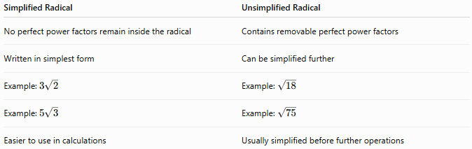
Simplified Radical | Unsimplified Radical
No perfect power factors remain inside the radical | Contains removable perfect power factors
Written in simplest form | Can be simplified further
Example: $3\sqrt{2}$ | Example: $\sqrt{18}$
Example: $5\sqrt{3}$ | Example: $\sqrt{75}$
Easier to use in calculations | Usually simplified before further operations

Conclusion
# Source: AI Source: Provided by: [Data Path: Persons Table -> ID Column: 1, Name_En Column: Motasem Essam] -> From: [ChatGPT] on [7/11/2026]
Simplifying Radicals is the process of rewriting radical expressions in their simplest equivalent form by extracting perfect powers from the radicand. It relies on properties of radicals, prime factorization, and exponent rules to produce expressions that are easier to manipulate and interpret. Simplified radicals are fundamental in arithmetic, algebra, geometry, science, engineering, and many real-world applications involving exact values.

Comparison
# Source: AI Source: Provided by: [Data Path: Persons Table -> ID Column: 1, Name_En Column: Motasem Essam] -> From: [ChatGPT] on [7/11/2026]
Comparison of Whole Numbers is the process of determining the relationship between two or more whole numbers based on their values. It identifies whether one number is greater than, less than, or equal to another.
Comparison is a fundamental operation in arithmetic and is widely used in mathematics, computer science, finance, science, engineering, and everyday decision-making.

Definition
# Source: AI Source: Provided by: [Data Path: Persons Table -> ID Column: 1, Name_En Column: Motasem Essam] -> From: [ChatGPT] on [7/11/2026]
Whole Number Comparison is the process of comparing the values of two or more whole numbers using comparison symbols.
The possible outcomes are:
- Greater than
- Less than
- Equal to
- Greater than or equal to
- Less than or equal to

Comparison Symbols
# Source: AI Source: Provided by: [Data Path: Persons Table -> ID Column: 1, Name_En Column: Motasem Essam] -> From: [ChatGPT] on [7/11/2026]
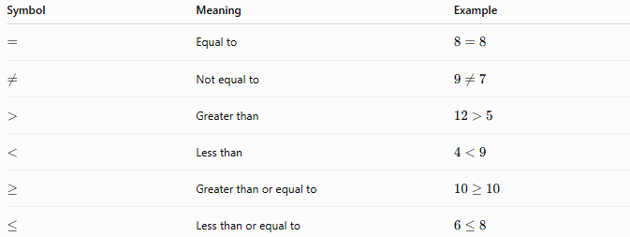
Symbol | Meaning | Example
$$=$$ | Equal to | $$8=8$$
$$≠$$ | Not equal to | $$9≠7$$
$$>$$ | Greater than | $$12>5$$
$$<$$ | Less than | $$4<9$$
$$≥$$ | Greater than or equal to | $$10≥10$$
$$≤$$ | Less than or equal to | $$6≤8$$

Rules for Comparing Whole Numbers

1. Compare the Number of Digits
# Source: AI Source: Provided by: [Data Path: Persons Table -> ID Column: 1, Name_En Column: Motasem Essam] -> From: [ChatGPT] on [7/11/2026]
A whole number with more digits is greater than a whole number with fewer digits.
Examples
$$582>94$$
because
582 has 3 digits, while 94 has 2 digits.

$$10 000>999$$
because
10,000 has 5 digits, while 999 has 3 digits.

2. Compare Digits from Left to Right
# Source: AI Source: Provided by: [Data Path: Persons Table -> ID Column: 1, Name_En Column: Motasem Essam] -> From: [ChatGPT] on [7/11/2026]
If both numbers have the same number of digits, compare corresponding digits starting from the leftmost digit.
Example
Compare
$$5482$$
and
$$5439.$$
Thousands:
$$5=5$$
Hundreds:
$$4=4$$
Tens:
$$8>3$$
Therefore,
$$5482>5439.$$

3. Continue Comparing Until the First Different Digit
# Source: AI Source: Provided by: [Data Path: Persons Table -> ID Column: 1, Name_En Column: Motasem Essam] -> From: [ChatGPT] on [7/11/2026]
Ignore equal leading digits until the first unequal pair is found.
Example
Compare
$$70518$$
and
$$70506.$$
The first three digits are equal.
Compare the fourth digit:
$$1>0.$$
Therefore,
$$70518>70506.$$

4. Equal Numbers
# Source: AI Source: Provided by: [Data Path: Persons Table -> ID Column: 1, Name_En Column: Motasem Essam] -> From: [ChatGPT] on [7/11/2026]
If every corresponding digit is identical, the numbers are equal.
Example
$$45892=45892.$$

5. Compare Zero
# Source: AI Source: Provided by: [Data Path: Persons Table -> ID Column: 1, Name_En Column: Motasem Essam] -> From: [ChatGPT] on [7/11/2026]
Zero is the smallest whole number.
Examples
$$0<1 \\ 0<100 \\ 0=0$$

6. Compare Multiple Whole Numbers
# Source: AI Source: Provided by: [Data Path: Persons Table -> ID Column: 1, Name_En Column: Motasem Essam] -> From: [ChatGPT] on [7/11/2026]
Arrange numbers from smallest to largest (ascending) or largest to smallest (descending).
Ascending Order
Arrange
$$42, 9, 315, 101 \\ 9<42<101<315.$$
Descending Order
$$315>101>42>9.$$

7. Use Place Value
# Source: AI Source: Provided by: [Data Path: Persons Table -> ID Column: 1, Name_En Column: Motasem Essam] -> From: [ChatGPT] on [7/11/2026]
Compare digits according to their place values.
Example
Compare
$$7325$$
and
$$7235.$$
Thousands:
$$7=7$$
Hundreds:
$$3>2$$
Therefore,
$$7325>7235.$$

Examples
# Source: AI Source: Provided by: [Data Path: Persons Table -> ID Column: 1, Name_En Column: Motasem Essam] -> From: [ChatGPT] on [7/11/2026]
Example 1
Compare
$$25$$
and
$$52.$$
Since
$$2<5$$
in the tens place,
$$25<52.$$

Example 2
Compare
$$802$$
and
$$799.$$
802 has more hundreds.
$$802>799.$$

Example 3
Compare
$$5000$$
and
$$5000.$$
All digits are identical.
$$5000=5000.$$

Example 4
Arrange in ascending order:
$$74, 9, 120, 48.$$
Answer:
$$9<48<74<120.$$

Example 5
Arrange in descending order:
$$18, 405, 76, 999.$$
Answer:
$$999>405>76>18.$$

Example 6
Compare
$$10001$$
and
$$10010.$$
Compare from left to right.
The first different digit is in the tens place:
$$0<1.$$
Therefore,
$$10001<10010.$$

Applications
# Source: AI Source: Provided by: [Data Path: Persons Table -> ID Column: 1, Name_En Column: Motasem Essam] -> From: [ChatGPT] on [7/11/2026]
Whole number comparison is used in:
- Arithmetic
- Number ordering
- Sorting algorithms
- Databases
- Programming
- Finance
- Statistics
- Scientific measurements
- Inventory management
- Ranking systems

Properties
# Source: AI Source: Provided by: [Data Path: Persons Table -> ID Column: 1, Name_En Column: Motasem Essam] -> From: [ChatGPT] on [7/11/2026]
- Every pair of whole numbers can be compared.
- Exactly one of the following is always true:
  - $a<b$
  - $a=b$
  - $a>b$
- Comparison is based on place value.
- Whole numbers have a natural order.
- Zero is the smallest whole number.

Real-Life Applications
# Source: AI Source: Provided by: [Data Path: Persons Table -> ID Column: 1, Name_En Column: Motasem Essam] -> From: [ChatGPT] on [7/11/2026]
Whole number comparison is used in:
- Comparing prices
- Comparing populations
- Comparing distances
- Exam scores
- Sports rankings
- Inventory counts
- Bank account balances
- Computer algorithms
- Data sorting
- Age comparisons

Real-Life Examples
# Source: AI Source: Provided by: [Data Path: Persons Table -> ID Column: 1, Name_En Column: Motasem Essam] -> From: [ChatGPT] on [7/11/2026]
1. Shopping
Compare two product prices to determine which costs more.

2. School
Compare students' test scores to determine higher and lower scores.

3. Sports
Rank teams based on their total points.

4. Banking
Compare account balances.

5. Programming
Sorting algorithms repeatedly compare numbers to arrange data.

6. Census Data
Governments compare city populations to allocate resources.

Common Mistakes
# Source: AI Source: Provided by: [Data Path: Persons Table -> ID Column: 1, Name_En Column: Motasem Essam] -> From: [ChatGPT] on [7/11/2026]
- Comparing only the last digit instead of using place value.
- Assuming a longer-looking number is always larger without counting digits.
- Ignoring place value when numbers have the same number of digits.
- Confusing the symbols < and >.
- Forgetting that 0 is the smallest whole number.

Key Points
# Source: AI Source: Provided by: [Data Path: Persons Table -> ID Column: 1, Name_En Column: Motasem Essam] -> From: [ChatGPT] on [7/11/2026]
- Whole number comparison determines whether one number is greater than, less than, or equal to another.
- Compare the number of digits first.
- If the numbers have the same number of digits, compare digits from left to right.
- Use place value to identify the first differing digit.
- Zero is the smallest whole number.
- Comparison is essential for ordering, sorting, and decision-making.

Whole Number Comparison vs. Ordering Whole Numbers
# Source: AI Source: Provided by: [Data Path: Persons Table -> ID Column: 1, Name_En Column: Motasem Essam] -> From: [ChatGPT] on [7/11/2026]
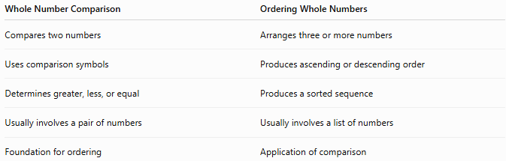
Whole Number Comparison | Ordering Whole Numbers
Compares two numbers | Arranges three or more numbers
Uses comparison symbols | Produces ascending or descending order
Determines greater, less, or equal | Produces a sorted sequence
Usually involves a pair of numbers | Usually involves a list of numbers
Foundation for ordering | Application of comparison

Conclusion
# Source: AI Source: Provided by: [Data Path: Persons Table -> ID Column: 1, Name_En Column: Motasem Essam] -> From: [ChatGPT] on [7/11/2026]
Whole Number Comparison is the process of determining the relative values of whole numbers using comparison symbols such as <, >, and =. By comparing the number of digits and then comparing corresponding digits from left to right using place value, any two whole numbers can be accurately compared. This skill is fundamental to arithmetic and is widely used in mathematics, computing, finance, science, and everyday life.

Ordering
# Source: AI Source: Provided by: [Data Path: Persons Table -> ID Column: 1, Name_En Column: Motasem Essam] -> From: [ChatGPT] on [7/11/2026]
Ordering Whole Numbers is the process of arranging two or more whole numbers according to their values, either from smallest to largest (ascending order) or from largest to smallest (descending order).
Ordering whole numbers is based on whole number comparison and the place value system. It is a fundamental arithmetic skill used in mathematics, computer science, data analysis, finance, and everyday life.

Definition
# Source: AI Source: Provided by: [Data Path: Persons Table -> ID Column: 1, Name_En Column: Motasem Essam] -> From: [ChatGPT] on [7/11/2026]
Ordering Whole Numbers is the process of arranging whole numbers according to their numerical values.
The two common types of ordering are:
- Ascending Order (smallest to largest)
- Descending Order (largest to smallest)

Types of Ordering

1. Ascending Order
# Source: AI Source: Provided by: [Data Path: Persons Table -> ID Column: 1, Name_En Column: Motasem Essam] -> From: [ChatGPT] on [7/11/2026]
Numbers are arranged from the smallest value to the largest value.
Example
Arrange
$$45, 9, 123, 78$$
in ascending order.
$$9<45<78<123$$

2. Descending Order
# Source: AI Source: Provided by: [Data Path: Persons Table -> ID Column: 1, Name_En Column: Motasem Essam] -> From: [ChatGPT] on [7/11/2026]
Numbers are arranged from the largest value to the smallest value.
Example
Arrange
$$45, 9, 123, 78$$
in descending order.
$$123>78>45>9$$

Rules for Ordering Whole Numbers

1. Compare the Number of Digits
# Source: AI Source: Provided by: [Data Path: Persons Table -> ID Column: 1, Name_En Column: Motasem Essam] -> From: [ChatGPT] on [7/11/2026]
A whole number with more digits is greater than one with fewer digits.
Example
Arrange
$$98, 1002, 405$$
Ascending:
$$98<405<1002$$

2. Compare Digits from Left to Right
# Source: AI Source: Provided by: [Data Path: Persons Table -> ID Column: 1, Name_En Column: Motasem Essam] -> From: [ChatGPT] on [7/11/2026]
If numbers have the same number of digits, compare corresponding digits starting from the leftmost digit.
Example
Arrange
$$5482, 5439, 5461$$
Ascending:
$$5439<5461<5482$$

3. Use Place Value
# Source: AI Source: Provided by: [Data Path: Persons Table -> ID Column: 1, Name_En Column: Motasem Essam] -> From: [ChatGPT] on [7/11/2026]
Compare digits according to their place values until the first difference is found.
Example
Arrange
$$7325, 7235, 7352$$
Ascending:
$$7235<7325<7352$$

4. Zero Comes First in Ascending Order
# Source: AI Source: Provided by: [Data Path: Persons Table -> ID Column: 1, Name_En Column: Motasem Essam] -> From: [ChatGPT] on [7/11/2026]
Since zero is the smallest whole number, it appears first when arranging numbers in ascending order.
Example
Arrange
$$14, 0, 8, 25$$
Ascending:
$$0<8<14<25$$

5. Reverse the Ascending Order to Obtain Descending Order
# Source: AI Source: Provided by: [Data Path: Persons Table -> ID Column: 1, Name_En Column: Motasem Essam] -> From: [ChatGPT] on [7/11/2026]
Descending order is simply the reverse of ascending order.
Example
Ascending:
$$3<18<57<104$$
Descending:
$$104>57>18>3$$

6. Equal Numbers Remain Together
# Source: AI Source: Provided by: [Data Path: Persons Table -> ID Column: 1, Name_En Column: Motasem Essam] -> From: [ChatGPT] on [7/11/2026]
If two or more numbers are equal, they occupy the same relative position in the ordered list.
Example
Arrange
$$25, 12, 25, 8$$
Ascending:
$$8<12<25=25$$

7. Ordering Is Based on Comparison
# Source: AI Source: Provided by: [Data Path: Persons Table -> ID Column: 1, Name_En Column: Motasem Essam] -> From: [ChatGPT] on [7/11/2026]
Before ordering, compare the numbers to determine their relative sizes.
Example
Arrange
$$601, 609, 590, 615$$
Ascending:
$$590<601<609<615$$

Examples
# Source: AI Source: Provided by: [Data Path: Persons Table -> ID Column: 1, Name_En Column: Motasem Essam] -> From: [ChatGPT] on [7/11/2026]
Example 1
Arrange in ascending order:
$$42, 9, 315, 101$$
Answer:
$$9<42<101<315$$

Example 2
Arrange in descending order:
$$18, 405, 76, 999$$
Answer:
$$999>405>76>18$$

Example 3
Arrange in ascending order:
$$500, 50, 5000, 5$$
Answer:
$$5<50<500<5000$$

Example 4
Arrange in descending order:
$$802, 799, 810, 805$$
Answer:
$$810>805>802>799$$

Example 5
Arrange in ascending order:
$$10001, 10010, 10000, 10011$$
Answer:
$$10000<10001<10010<10011$$

Example 6
Arrange in descending order:
$$0, 4, 100, 25, 8$$
Answer:
$$100>25>8>4>0$$

Applications
# Source: AI Source: Provided by: [Data Path: Persons Table -> ID Column: 1, Name_En Column: Motasem Essam] -> From: [ChatGPT] on [7/11/2026]
Ordering whole numbers is used in:
- Arithmetic
- Data sorting
- Ranking systems
- Statistics
- Programming
- Database management
- Financial reports
- Scientific measurements
- Inventory management
- Scheduling

Properties
# Source: AI Source: Provided by: [Data Path: Persons Table -> ID Column: 1, Name_En Column: Motasem Essam] -> From: [ChatGPT] on [7/11/2026]
- Ordering is based on comparison.
- Every set of whole numbers has a unique ascending order.
- Every set of whole numbers has a unique descending order.
- Zero is the smallest whole number.
- Place value determines the order of numbers with the same number of digits.
- Equal numbers remain equal in the ordered list.

Real-Life Applications
# Source: AI Source: Provided by: [Data Path: Persons Table -> ID Column: 1, Name_En Column: Motasem Essam] -> From: [ChatGPT] on [7/11/2026]
Ordering whole numbers is used in:
- Ranking students by scores
- Sorting prices from lowest to highest
- Organizing populations by size
- Ordering product quantities
- Arranging inventory counts
- Scheduling tasks by priority
- Sorting files by size
- Organizing financial records
- Database indexing
- Search algorithms

Real-Life Examples
# Source: AI Source: Provided by: [Data Path: Persons Table -> ID Column: 1, Name_En Column: Motasem Essam] -> From: [ChatGPT] on [7/11/2026]
1. School Rankings
Students are ranked according to their examination scores.

2. Shopping
Products are sorted from the least expensive to the most expensive.

3. Sports
Teams are ordered by total points.

4. Banking
Account balances are listed from highest to lowest.

5. Computer Science
Sorting algorithms arrange numbers in ascending or descending order.

6. Statistics
Data values are ordered before finding the median or quartiles.

Common Mistakes
# Source: AI Source: Provided by: [Data Path: Persons Table -> ID Column: 1, Name_En Column: Motasem Essam] -> From: [ChatGPT] on [7/11/2026]
- Comparing only the last digit instead of using place value.
- Forgetting that numbers with more digits are generally larger.
- Confusing ascending and descending order.
- Ignoring equal numbers in the list.
- Misreading comparison symbols.
- Forgetting that 0 is the smallest whole number.

Key Points
# Source: AI Source: Provided by: [Data Path: Persons Table -> ID Column: 1, Name_En Column: Motasem Essam] -> From: [ChatGPT] on [7/11/2026]
- Ordering whole numbers means arranging them according to their values.
- Ascending order goes from smallest to largest.
- Descending order goes from largest to smallest.
- Compare the number of digits first.
- If necessary, compare digits from left to right using place value.
- Ordering depends on accurate comparison.
- Ordering is essential in mathematics, computing, science, and everyday life.

Whole Number Ordering vs. Whole Number Comparison
# Source: AI Source: Provided by: [Data Path: Persons Table -> ID Column: 1, Name_En Column: Motasem Essam] -> From: [ChatGPT] on [7/11/2026]
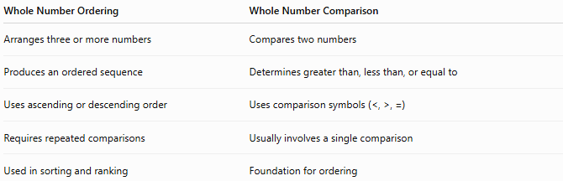
Whole Number Ordering | Whole Number Comparison
Arranges three or more numbers | Compares two numbers
Produces an ordered sequence | Determines greater than, less than, or equal to
Uses ascending or descending order | Uses comparison symbols (<, >, =)
Requires repeated comparisons | Usually involves a single comparison
Used in sorting and ranking | Foundation for ordering

Conclusion
# Source: AI Source: Provided by: [Data Path: Persons Table -> ID Column: 1, Name_En Column: Motasem Essam] -> From: [ChatGPT] on [7/11/2026]
Ordering Whole Numbers is the process of arranging whole numbers from smallest to largest (ascending order) or from largest to smallest (descending order). It relies on comparing the number of digits and the place values of corresponding digits to determine the correct sequence. Ordering is a fundamental arithmetic skill that supports sorting, ranking, data analysis, programming, finance, and many real-world applications.

Find Numbers

One number between two numbers

Definition
# Source: AI Source: Provided by: [Data Path: Persons Table -> ID Column: 1, Name_En Column: Motasem Essam] -> From: [ChatGPT] on [7/11/2026]
Finding a number between two whole numbers means identifying one or more numbers whose values are greater than the smaller whole number and less than the larger whole number.
If the two numbers are consecutive whole numbers (such as 5 and 6), no whole number exists between them. However, infinitely many fractions and decimals exist between any two distinct whole numbers.

When Whole Numbers Exist Between Them
# Source: AI Source: Provided by: [Data Path: Persons Table -> ID Column: 1, Name_En Column: Motasem Essam] -> From: [ChatGPT] on [7/11/2026]
If the difference between the two whole numbers is greater than 1:
$$b-a>1$$
then one or more whole numbers lie between them.
Example
Between:
$$3 \text{and} 8$$
The whole numbers between them are:
$$4, 5, 6, 7$$

When No Whole Number Exists
# Source: AI Source: Provided by: [Data Path: Persons Table -> ID Column: 1, Name_En Column: Motasem Essam] -> From: [ChatGPT] on [7/11/2026]
If the numbers are consecutive:
$$a, a+1$$
there is no whole number between them.
Example
Between:
$$7 \text{and} 8$$
there is no whole number.

Finding One Number Between Two Whole Numbers
# Source: AI Source: Provided by: [Data Path: Persons Table -> ID Column: 1, Name_En Column: Motasem Essam] -> From: [ChatGPT] on [7/11/2026]
A convenient method is to calculate the midpoint.
If the midpoint is a whole number, then it lies between them.
$$\text{Middle Number}=\frac{a+b}{2}$$
Example
Between:
$$10 \text{and} 14 \\ \frac{10+14}{2}=12$$
So:
$$12$$
is a whole number between them.

Examples
# Source: AI Source: Provided by: [Data Path: Persons Table -> ID Column: 1, Name_En Column: Motasem Essam] -> From: [ChatGPT] on [7/11/2026]
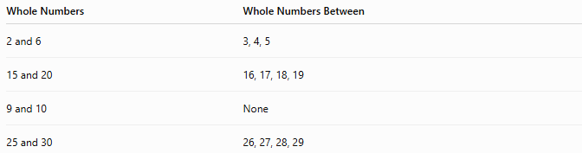
Whole Numbers | Whole Numbers Between
2 and 6 | 3, 4, 5
15 and 20 | 16, 17, 18, 19
9 and 10 | None
25 and 30 | 26, 27, 28, 29

Important Note
# Source: AI Source: Provided by: [Data Path: Persons Table -> ID Column: 1, Name_En Column: Motasem Essam] -> From: [ChatGPT] on [7/11/2026]
Although there may be no whole number between two consecutive whole numbers, there are infinitely many other numbers between them.
Example:
Between:
$$5 \text{and} 6$$
there are numbers such as:
$$5.1, 5.25, 5.5, 5.75, 5.99$$
and infinitely many more.

Applications
# Source: AI Source: Provided by: [Data Path: Persons Table -> ID Column: 1, Name_En Column: Motasem Essam] -> From: [ChatGPT] on [7/11/2026]
Finding numbers between whole numbers is used in:
- Arithmetic
- Number Lines
- Ordering Numbers
- Estimation
- Measurement
- Coordinate Geometry
- Data Analysis
- Computer Science

Key Points
# Source: AI Source: Provided by: [Data Path: Persons Table -> ID Column: 1, Name_En Column: Motasem Essam] -> From: [ChatGPT] on [7/11/2026]
- Whole numbers between two whole numbers exist only if their difference is greater than 1.
- Consecutive whole numbers have no whole number between them.
- The midpoint formula
$$\frac{a+b}{2}$$
can help find a number between them when it is a whole number.
- Between any two distinct whole numbers, there are infinitely many fractions and decimals.

Conclusion
# Source: AI Source: Provided by: [Data Path: Persons Table -> ID Column: 1, Name_En Column: Motasem Essam] -> From: [ChatGPT] on [7/11/2026]
Finding a number between two whole numbers involves determining whether another whole number lies strictly between them. If the numbers are not consecutive, one or more whole numbers exist between them. If they are consecutive, no whole number exists between them, although infinitely many fractional and decimal numbers do. This concept is fundamental in arithmetic, number theory, estimation, measurement, coordinate geometry, and mathematical reasoning.

More Than One Number Between two Numbers

Definition
# Source: AI Source: Provided by: [Data Path: Persons Table -> ID Column: 1, Name_En Column: Motasem Essam] -> From: [ChatGPT] on [7/11/2026]
Finding more than one number between two whole numbers means identifying all whole numbers (or a specified number of whole numbers) whose values are greater than the smaller whole number and less than the larger whole number.
This is only possible when the difference between the two whole numbers is greater than 2.

Condition
# Source: AI Source: Provided by: [Data Path: Persons Table -> ID Column: 1, Name_En Column: Motasem Essam] -> From: [ChatGPT] on [7/11/2026]
Let the two whole numbers be:
$$a \text{and} b$$
where
$$a<b$$
Whole numbers exist between them only if:
$$b-a>1$$
More than one whole number exists between them if:
$$b-a>2$$

Method
# Source: AI Source: Provided by: [Data Path: Persons Table -> ID Column: 1, Name_En Column: Motasem Essam] -> From: [ChatGPT] on [7/11/2026]
Starting from the smaller number:
- Add 1 repeatedly.
- Stop before reaching the larger number.
The resulting values are all the whole numbers between the two numbers.

Examples
# Source: AI Source: Provided by: [Data Path: Persons Table -> ID Column: 1, Name_En Column: Motasem Essam] -> From: [ChatGPT] on [7/11/2026]
Example 1
Find the whole numbers between:
$$4 \text{and} 10$$
The numbers are:
$$5, 6, 7, 8, 9$$

Example 2
Find the whole numbers between:
$$12 \text{and} 18$$
The numbers are:
$$13, 14, 15, 16, 17$$

Example 3
Find the whole numbers between:
$$25 \text{and} 31$$
The numbers are:
$$26, 27, 28, 29, 30$$

Number of Whole Numbers Between Two Whole Numbers
# Source: AI Source: Provided by: [Data Path: Persons Table -> ID Column: 1, Name_En Column: Motasem Essam] -> From: [ChatGPT] on [7/11/2026]
The number of whole numbers between:
$$a \text{and} b$$
is
$$\left(b-a\right)-1$$

Example
Between:
$$15 \text{and} 24$$
Number of whole numbers:
$$\left(24-15\right)-1=8$$
The numbers are:
$$16, 17, 18, 19, 20, 21, 22, 23$$

Special Cases

Consecutive Whole Numbers
# Source: AI Source: Provided by: [Data Path: Persons Table -> ID Column: 1, Name_En Column: Motasem Essam] -> From: [ChatGPT] on [7/11/2026]
Between:
$$8 \text{and} 9$$
there are no whole numbers.

Only One Whole Number
# Source: AI Source: Provided by: [Data Path: Persons Table -> ID Column: 1, Name_En Column: Motasem Essam] -> From: [ChatGPT] on [7/11/2026]
Between:
$$6 \text{and} 8$$
there is only:
$$7$$

Applications
# Source: AI Source: Provided by: [Data Path: Persons Table -> ID Column: 1, Name_En Column: Motasem Essam] -> From: [ChatGPT] on [7/11/2026]
Finding multiple whole numbers between two whole numbers is used in:
- Arithmetic
- Number Lines
- Number Ordering
- Counting
- Estimation
- Mathematics Education
- Computer Programming
- Data Organization

Key Points
# Source: AI Source: Provided by: [Data Path: Persons Table -> ID Column: 1, Name_En Column: Motasem Essam] -> From: [ChatGPT] on [7/11/2026]
- More than one whole number exists between two whole numbers only when:
$$b-a>2$$
- All intermediate whole numbers are found by counting upward from the smaller number until just before the larger number.
- The number of whole numbers between two whole numbers is:
$$\left(b-a\right)-1$$

Conclusion
# Source: AI Source: Provided by: [Data Path: Persons Table -> ID Column: 1, Name_En Column: Motasem Essam] -> From: [ChatGPT] on [7/11/2026]
Finding more than one whole number between two whole numbers involves listing every whole number greater than the smaller number and less than the larger number. This is possible whenever the numbers are separated by at least three units, and the total count of intermediate whole numbers is given by $\left(b-a\right)-1$. This concept is fundamental in arithmetic, number lines, counting, ordering numbers, estimation, programming, and mathematical reasoning.

Finding Two Consecutive Numbers That a Number Lies Between

Definition
# Source: AI Source: Provided by: [Data Path: Persons Table -> ID Column: 1, Name_En Column: Motasem Essam] -> From: [ChatGPT] on [7/11/2026]
Finding the two consecutive whole numbers around a whole number means identifying the immediately preceding and immediately succeeding whole numbers.
If the given whole number is:
$$n$$
then the two consecutive whole numbers around it are:
$$n-1 \text{and} n+1$$
The given whole number lies exactly between these two consecutive whole numbers.

Rule
# Source: AI Source: Provided by: [Data Path: Persons Table -> ID Column: 1, Name_En Column: Motasem Essam] -> From: [ChatGPT] on [7/11/2026]
For any whole number:
$$n$$
the surrounding consecutive whole numbers are:
$$n-1, n+1$$

Examples
# Source: AI Source: Provided by: [Data Path: Persons Table -> ID Column: 1, Name_En Column: Motasem Essam] -> From: [ChatGPT] on [7/11/2026]
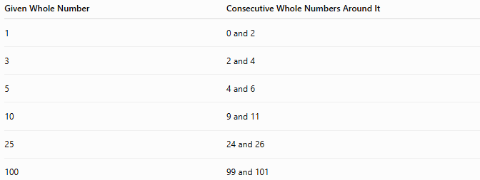
Given Whole Number | Consecutive Whole Numbers Around It
1 | 0 and 2
3 | 2 and 4
5 | 4 and 6
10 | 9 and 11
25 | 24 and 26
100 | 99 and 101

Illustration
# Source: AI Source: Provided by: [Data Path: Persons Table -> ID Column: 1, Name_En Column: Motasem Essam] -> From: [ChatGPT] on [7/11/2026]
Example 1
Given:
$$5$$
4 ─── 5 ─── 6
The whole number 5 lies between the consecutive whole numbers:
$$4\text{ and }6$$

Example 2
Given:
$$12$$
11 ─── 12 ─── 13
The whole number 12 lies between:
$$11\text{ and }13$$

Properties
# Source: AI Source: Provided by: [Data Path: Persons Table -> ID Column: 1, Name_En Column: Motasem Essam] -> From: [ChatGPT] on [7/11/2026]
- The surrounding numbers are always consecutive.
- The given whole number is exactly 1 greater than the previous whole number.
- The given whole number is exactly 1 less than the next whole number.
- The difference between the surrounding numbers is always:
$$2$$

Mathematical Representation
# Source: AI Source: Provided by: [Data Path: Persons Table -> ID Column: 1, Name_En Column: Motasem Essam] -> From: [ChatGPT] on [7/11/2026]
If the whole number is:
$$n$$
then:
Previous whole number:
$$n-1$$
Next whole number:
$$n+1$$

Applications
# Source: AI Source: Provided by: [Data Path: Persons Table -> ID Column: 1, Name_En Column: Motasem Essam] -> From: [ChatGPT] on [7/11/2026]
This concept is used in:
- Arithmetic
- Number Patterns
- Number Lines
- Counting
- Estimation
- Mathematics Education

Key Points
# Source: AI Source: Provided by: [Data Path: Persons Table -> ID Column: 1, Name_En Column: Motasem Essam] -> From: [ChatGPT] on [7/11/2026]
- Every whole number (except 0 for the previous whole number if restricting to non-negative whole numbers) has one whole number immediately before it and one immediately after it.
- If the number is:
$$n$$
then it lies between:
$$n-1 \text{and} n+1$$
- Example:
$$5\text{ lies between }4\text{ and }6.$$

Conclusion
# Source: AI Source: Provided by: [Data Path: Persons Table -> ID Column: 1, Name_En Column: Motasem Essam] -> From: [ChatGPT] on [7/11/2026]
Every whole number is positioned between its immediately preceding and immediately succeeding whole numbers. If the given whole number is $n$, then it lies between $n-1$and $n+1$, which are consecutive whole numbers. This concept is fundamental for understanding number order, number lines, counting, arithmetic patterns, and integer relationships.

